Tom Van Esbroeck

Chairman

Commission for Extrication & New Technology

Roggestraat 70

9400 Gent

Belgium

Tel.: +32 476 942 721

E-Mail: tom.vanesbroeck@gent.be

INVITATION VIENNA MEETING

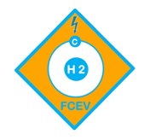

The 28th & 29th of May 2014

The CTIF Commission for "Extrication and New Technology" is trying to encourage and promote the cooperation between fire services and other emergency services around the world, representing 36 different countries via CTIF.

In the next few years, the commission wants to focus primarily on the development and exchange of “best practices” regarding extrication techniques for vehicles on alternative energy (Hydrogen, Electric, CNG, LNG, Li ION batteries, Super Capacitors etc)..

Besides exchanging experience, the commission also wants to draw up standard operational procedures regarding extrication of busses, trains and airplanes.

The commission will work within the ‘ISO’ (International Organization for Standardization) to be able to internationally harmonize information and training for the rescue services in the field.

If we can share our experiences on the international level, this will help us all one step further to guarantee the security of our citizens and emergency workers. The more we can learn from each other, the better.
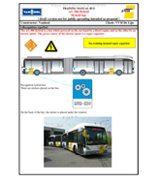

.

We look forward to hear from you.

Yours sincerely

Tom Van Esbroeck

Chairman

Commission for Extrication & New Technology

