CTIF Forest Fire Commission Meeting


Norway

17-20 november
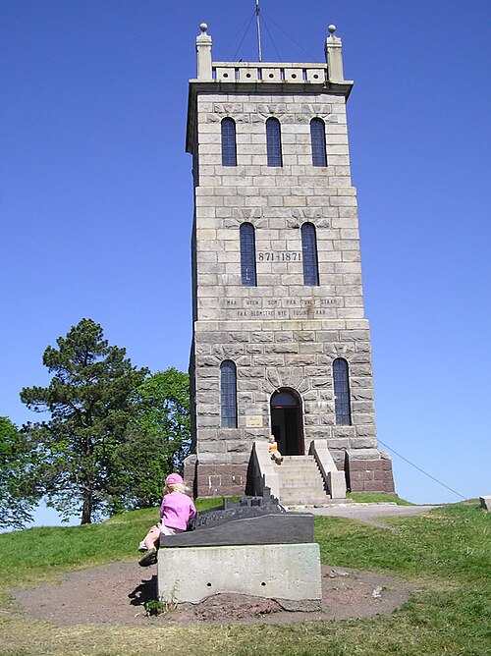  Slotsfjellet |  | Welcome to Norway and Tønsberg.  Tønsberg city claims to the oldest town in Norway, dating back 1000 years to the Viking age.  You travel to Tønsberg with plane to Oslo Gardermoen airport (OSL) or Sanderfjord lufthavn Torp (TRF). From both airport you can take train to Tønsberg.  Is a short walt from train station to our hotel Quality Hotel Tønsberg. We have a discount rate at the hotel.  Booking link to hotel:  https://app.mews.com/distributor/8dada58b-463c-4d2b-96d5-b122006cea6a?mewsAvailabilityBlockId=a2e2e4a8-3c39-4325-9c14-b4b700990baf&mewsStart=2026-11-16&mewsEnd=2026-11-20
Quality Hotel Tønsberg, Ollebukta 3, 3126 Tønsberg

Program CTIF meeting Norway 17-19 November
16.11 Arrival to Tønsberg
- Arrival to Tønsberg
- Hotel Check inn
- Informal networking (optional)
- Dinner (optional)
17.11 - Day 1
08.00 -09.00 Registration of participants
09.00 Welcome to Tønsberg by the Mayor of the City, Frank Pedersen
09.10 Welkom to Norway by local fire chief Jan Helge Kaiser
09.15 Opening of meeting chairman Jean Marc Bedogni
09.30 Seminar Day - Large forest fires incidents I Europe 2026
Introduction Jean Marc
Prestation from country 1
Presentation from country 2
Presentation from Norway 3
Sponsor presentation Arctic Aviation , Richard Simonsen and Thorsten Habla Foss
12.30 -13.30 Lunch
Sponsor presentation Skjodr, Knut-Einar Wold
Presentation from country 4
Presentation from country 5
Presentation from country 6
Associated members presentation.
Visit Fire station in Tønsberg
19.00 Dinner
18.11 - Day 2 Commission meeting
09.00 Opening Day 2 Jean Marc Bedogni
Country presentation on season 2026 15 min each
Lesson learnt group discussions
Associated members presentation.
Lunch
Associated members presentation.
Group presentation
Visit our fire dispatch central 110 Sør Øst
19.00 Dinner
19.11 - Day 3
Formal business committee
Recommendation from the committee
Lunch
Open session for suggested topics
19.00 Dinner

20.11 – Departure home
CTIF Norway
Ove Stokkeland
+4793054318 | ove.stokkeland@gmail.com | ctif.no

