

European Hydrogen Train the Trainer Programme for Responders

Fuel Cells and Hydrogen Joint Undertaking (FCH JU)
Project Number: 875089
Project Acronym: HyResponder
Task 5.5

Deliverable 5.12

Recommendations on the Pan-European Recognition and Continuation of Hydrogen Safety Training for Responders

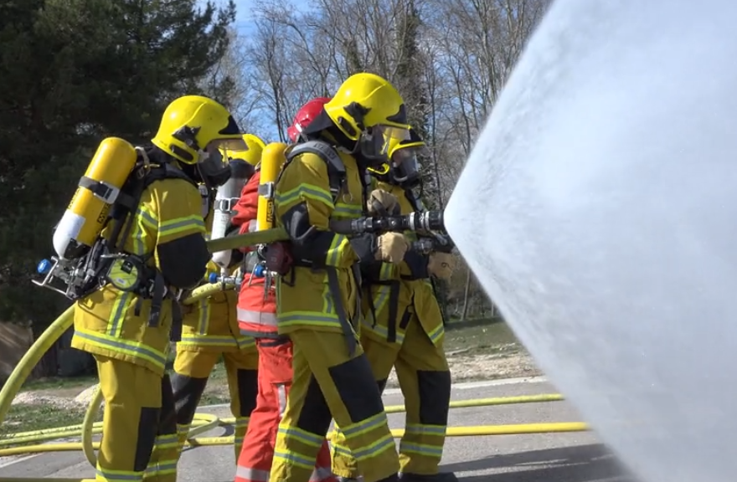

Lead Author: CTIF Dennis Davis
Submission date: May 2023
Due date: May 2023

History of changes

Version | Date | Change
1 | 16 November 2021 | CTIF Dennis Davis
2 | 19 July 2022 | CTIF Dennis Davis
3 | 1 November 2022 | CTIF Dennis Davis
4 | 25 April 2023 | CTIF Dennis Davis
5 | 16 May 2023 | CTIF Dennis Davis
6 | 30 May 2023 | CTIF Dennis Davis

Contents
PART 1 7
Summary 7
Section 1: Introduction 7
Section 2: European Fire Background 9
Section 3: Audience 10
Section 4: Evaluation 11
Evaluation Questionnaire 15
Section 5: Dissemination 16
Summary of Recommendations 17
PART 2 18
Framework for Firefighter Training in Hydrogen Safety 18
1 Purpose 18
2 Guidelines 19
3 Entrants Requirements 19
4 Objective 20
5 Training Centre Requirements 20
6 Unit Structure 21
7 Assessment 21
8 Recognised Prior Learning 22
9 Delivery 22
Framework Units 25
Unit 1 First Responder Safety 25
Objective 25
Essential resources 25
Learning Outcomes, Assessment Criteria and Explanation 25
Unit 2 Hydrogen Properties 26
Objective 26
Essential resources 26
Learning Outcomes, Assessment Criteria and Explanation 26
Unit 3 Storage Arrangements 27
Objective 27
Essential resources 27
Learning Outcomes, Assessment Criteria and Explanation 27
Unit 4 Hydrogen Interactions 28
Objective 28
Essential resources 28
Learning Outcomes, Assessment Criteria and Explanation 28
Unit 5 Liquefied Releases 29
Objective 29
Essential resources 29
Learning Outcomes, Assessment Criteria and Explanation 29
Unit 6 Threat for people and property 30
Objective 30
Essential resources 30
Learning Outcomes, Assessment Criteria and Explanation 30
Unit 7 Ignited Releases and Prevention 31
Objective 31
Essential resources 31
Learning Outcomes, Assessment Criteria and Explanation 31
Unit 8 Unignited Releases 32
Objective 32
Essential resources 32
Learning Outcomes, Assessment Criteria and Explanation 32
Unit 9 Hazard Distances 33
Objective 33
Essential resources 33
Learning Outcomes, Assessment Criteria and Explanation 33
Unit 10 Explosions 34
Objective 34
Essential resources 34
Learning Outcomes, Assessment Criteria and Explanation 34
Unit 11 Confined Spaces 35
Objective 35
Essential resources 35
Learning Outcomes, Assessment Criteria and Explanation 35
Unit 12 Refuelling Stations 36
Objective 36
Essential resources 36
Learning Outcomes, Assessment Criteria and Explanation 36
Unit 13 Standard Operating Practice 37
Objective 37
Essential resources 37
Learning Outcomes, Assessment Criteria and Explanation 37
Unit 14 Fuel Cell Vehicles 38
Objective 38
Essential resources 38
Learning Outcomes, Assessment Criteria and Explanation 38
Unit 15 Fuel Cell Buses 39
Objective 39
Essential resources 39
Learning Outcomes, Assessment Criteria and Explanation 39
Unit 16 Fuel Cell Trucks 40
Objective 40
Essential resources 40
Learning Outcomes, Assessment Criteria and Explanation 40
Unit 17 Fuel Cell Trains 41
Objective 41
Essential resources 41
Learning Outcomes, Assessment Criteria and Explanation 41
Unit 18 Trailers 42
Objective 42
Essential resources 42
Learning Outcomes, Assessment Criteria and Explanation 42
Unit 19 Industrial Refuelling Stations 43
Objective 43
Essential resources 43
Learning Outcomes, Assessment Criteria and Explanation 43
Unit 20 Generation Plant 44
Objective 44
Essential resources 44
Learning Outcomes, Assessment Criteria and Explanation 44
Intervention Strategy Notes 47
Operational Practice 1 RESCUE 47
Operational Practice 2 FIRE ON THE ELECTRICAL COMPONENTS 48
Operational Practice 3 EXTERNAL FIRE THREATENING Application or H2 storage 49
Operational Practice 4 IGNITED HYDROGEN LEAK 50
Operational Practice 5 IGNITED HYDROGEN LEAK 51
Operational Practice 6 UNIGNITED HYDROGEN LEAK 52
Tactical Notes 53
The incident commander must enlarge or reduce the safety perimeter, taking into account the reality of the situation and in particular, the capacity of the H₂, LH₂ (or O₂) tank concerned. 53
Tactic 1 FC CAR / FC FORKLIFT / FC BUS / FC TRUCKS / FC TRAINS / FC SHIP NO LEAK NO FIRE (technical alarm, work accident, road traffic accident) 53
Tactic 2 FC CAR / FC FORKLIFT / FC BUS / FC TRUCKS / FC TRAINS / FC SHIP H2 LEAK WITHOUT FIRE 55
Tactic 3 FC CAR / FC FORKLIFT / FC BUS / FC TRUCKS / FC TRAINS / FC SHIP FIRE 57
Tactic 4 FC CAR / FC FORKLIFT / FC BUS / FC TRUCKS / FC TRAINS / FC SHIP EXTERNAL FIRE THREATENING THE APPLICATION 59
Tactic 5 H2 (LH2) Trailer NO LEAK NO FIRE (technical alarm, work accident, road traffic accident) 61
Tactic 6 H2 Trailer H2 LEAK WITHOUT FIRE 63
Tactic 7 H2 Trailer FIRE 65
Tactic 8 H2 Trailer EXTERNAL FIRE THREATENING THE APPLICATION 67
Tactic 9 REFUELLING STATION NO LEAK NO FIRE (technical alarm, work accident, road traffic accident) 69
Tactic 10 REFUELLING STATION H2 LEAK WITHOUT FIRE 71
Tactic 11 REFUELLING STATION FIRE 73
Tactic 12 REFUELLING STATION EXTERNAL FIRE THREATENING THE APPLICATION 75
Tactic 13 Stationary power generation unit (SPGU) / Hydrogen-based energy storage system NO LEAK NO FIRE (technical alarm) 77
Tactic 14 Stationary power generation unit (SPGU) / Hydrogen-based energy storage system H2 LEAK WITHOUT FIRE 79
Tactic 15 Stationary power generation unit (SPGU) / Hydrogen-based energy storage system FIRE 81
Tactic 16 Stationary power generation unit (SPGU) / Hydrogen-based energy storage system EXTERNAL FIRE THREATENING THE APPLICATION 84

PART 1

Summary

This report is prepared in two parts; Part 1 reports findings and recommendations developed from study and discussions during the evolution of the project, Part 2 describes in detail a proposed Training Framework for Firefighters created using the recommendations.

This approach was adopted to reflect what is considered to be a realistic prospect of sustaining the value of the project by utilising the training materials and practices observed during implementation of a ‘train the trainers’ programme that was produced as part of the project.

Verification of this approach inevitably became restricted, partly because the global pandemic restricted national training opportunities so restricting observation and evaluation of the Framework in practice, and partly because to maintain progress in overall project development national events proceeded in a number of cases in advance of the Framework.

Although these circumstances dictated ultimately how this task was accomplished it is considered that the overall approach, described in Part 1 focused on principle issues, and, in Part 2, the construction of training frameworks that have clear knowledge and practice elements, allows implementation of practical skill-based programmes suitable for first responders.

The Part 2 approach, it is considered, would also support easier revision and updating of a training programme. Maintaining current relevance to the changing operational environment, is an important feature for all emergency first responders who require constant preparedness to meet innovative changes in areas such as the alternative fuel technology upon which this project is centred.

Future proofing in this way both allows and supports adaptation to meet new demands and challenges in the external environment whilst also aiding adoption to meet localised controls and constraints that impact upon possible delivery. Retaining harmonised important safety information and sharing information on tactical operational practices is therefore a core of the framework to achieve this advantage.

Section 1: Introduction

HyResponder Task 5.5 aims to make recommendations on the Pan-European recognition and continuation of hydrogen safety training for responders. It has addressed this issue by considering the development of training aimed at firefighters, a key first responder group, by considering the activities undertaken by the consortium members as they developed ‘train the trainer’ experiences and materials to enable national training institutions develop their own programmes.

Firefighter training in Europe, like all first responder training has to be capable and flexible enough to encompass the wide diversity of emergency first responder arrangements that exist throughout Europe.

This diversity founded in the principles of subsidiarity and member state legislation and the historical and practical development of emergency response places considerable constraint on the opportunities for standardisation of delivery in any training and hence the approach used to seek and secure localised arrangements to develop and promote acceptable practice standards using the HyResponder training outcomes.

The objective therefore has been to try and ensure the training being developed is accepted and adopted by as many first responders as possible to help sustain the educational gains from HyResponder and to secure comparability of practice to aid interoperability at hydrogen related emergencies.

Although this element of the project work programme was not required to be delivered until Month 36 because the ‘train the trainer’ activity was already underway it was important to capture the evolution of learning and material as it was being created and used in the pilot projects.

This resulted in attending a practical training event organised to train first responder trainers, monitoring and discussing the programme as it was being developed and then developing a framework that could be adopted as the foundation course in hydrogen safety training for first responder firefighters. The framework once prepared was then subjected to review by a range of partners who were ether in the process of or about to deliver training in their national setting.

The outcome has been a series of interconnected actions culminating in a training framework that relates to multiple scenarios that anticipate emergency event involving hydrogen.

Initially this required the:

- differentiation and identification of learning and safety materials to aid specific roles of responders (firefighters, crew commander, incident commander and specialist adviser);
- collation, preparation and distribution of a draft framework for the firefighter role;
- observation of practical tactics and discussion with experienced trainers around the draft framework resulting in subsequent revision and redistribution; and
- review and evaluation of the framework as developed for adoption.

The framework in the finalised form has then been promoted to the global firefighter community through the internet with links to the national partners who have or are intending to implement supportive training or events that encourage use of the HyResponder eplatform and learning materials developed during the project with the clear intent of encouraging adoption and ensuring sustainability.

This approach is considered essential reflecting both jurisdiction accountability and standardisation limitations. Accountability for fire and emergency response services, civil protection, is both a member state subsidiarity matter and may in many European and non EU countries be devolved to regional or local municipalities or agencies.

Likewise standards surrounding training often have to meet national, localised and approved standard operating procedures. The process of obtaining and satisfying these various and defined verification and assurance requirements can be both time consuming and highly defined.

A consequence of these two features is that a framework, rather than a formal standard, was suggested for promotion for adoption and adaptation as the most appropriate way to introduce a harmonised methodology. This approach is also supported after evaluation the design framework by those experienced trainers involved in the project.

Recommendation 1: A Training Framework approach be adopted to secure widespread adoption rather than seek a formal European standard.

Section 2: European Fire Background

The first responder firefighter training programme envisaged in the project was seen as needing to offer a personal development and assessment opportunity capable of interpretation in the widest context of Europe.

To achieve this objective and to be sustainable it is necessary to both reflect significant local diversity; fire services can operate within national, regional or local governance, and; to reach the widest group of students many of whom may have limited available time.

This as outlined earlier is because tin the fire and rescue workforce many are volunteer responders, estimates are that they represent the majority of firefighters in the EU who are part of a group of over two million volunteer firefighters. Many in this group of firefighters may also have limited access to suitable training facilities due to isolation or funding issues, which again imposes availability constraints on both students and training delivery facilities and staff.

In addition the design process discussions established the proposed framework, in the fire service trainers’ judgements, was any framework required a programme capable of adoption and adaption; it could not be imposed. This confirmed the recommended approach and it was therefore seen as essential, to secure sustainability, that goodwill and support for any European Framework or similar programme by fire and rescue services, had to be an objective.

This also recognised, as outlined in the introduction, that the provision of fire and civil protection functions are derogated matters within the European Union with decisions resting within Member States. The specific fire training organisations likely to be engaged in this programme are largely dependent upon these authorities who have ultimate jurisdiction for the prioritisation, including funding, of the project’s recommended programme.

Widespread adoption however would benefit the European Union Civil Protection Mechanism by providing a foundation of common understanding within a fragmented area of localised practices.

Further the absence of a singular empowered central fire academic or learning environment has to be recognised, although it is accepted there exist some institutional and educational coordination arrangements. As a consequence the utilisation of open learning and a principled approach are foreseen as particularly important to programme sustainability and is the approach recommended.

Part of the development programme has included attendance at a “train the trainers” workshop held in June 2022 at the French fire academy for senior fire officers, Ecole Nationale Supérieure des Officiers de Sapeurs-Pompiers (ENSOSP). The ENSOSP workshop involved delivery of instructional material and practical live demonstrations of operational fire and leak control tactics using the knowledge, skills, experience and practices gained by ENSOSP instructional staff over a period of years. A report following this visit is available and again illustrates that common understanding and adoption of some form of common operational tactics is feasible.

Recommendation 2: An open access approach to captured learning materials should be maintained to assist the sustainability and continued improvement of the project.

Recommendation 3: Focusing on principles, for example on scientific matters, would aid maintenance of sustainability and allow flexibility to support local adoption and adaption to other first responder disciplines.

Section 3: Audience

In early discussions regarding sustainability of the training it was identified that the largest benefit would be derived if the first responders making the initial attendance at an emergency event could be provided with appropriate knowledge, skills and experience. That group was determined by the consortium to be the target audience and is that of a firefighter.

This choice reflects both a functional need: this is the group that must ensure the public and their own safety by identifying and securing the area of threat, exercise initial judgements as to operational tactics, deployment of resources, containment and rescues; and as fire and rescue first responders generally follow the same initial training route and behave in accordance with local standard operating procedures, this would ensure operational capabilities were successfully aligned.

In addition due to the limited opportunity many first responders have to personally develop due to practical considerations, like the time available to fulfil their role due to the voluntary practice of their work and ease of availability to trainers and training facilities, make it appropriate to design any training with this audience firmly as the initial target.

It must be noted this does not reflect any conflict regarding the professionalism of volunteer first responders, on the contrary, in many communities these individuals hold highly visible and professional roles, it is access and time to learn that create more difficult learning circumstances than for career or fulltime working responders.

A second target, given the background described earlier and the requirement to adopt and adapt the programme is to establish an appropriate educational level. This has nominally been achieved by referencing the programme to the recognised European Qualification Framework, regarded as the best benchmark to achieve a suitable comparability standard. Used by many first responders in Europe, including the fire and rescue service, EQF is well recognised as being the educational foundation for many vocational based qualifications such as those related to operational response.

Although materials are being developed across all operational management levels, it is considered a common or core set of materials focused on the firefighter and aligned to the EQF level 2 would be appropriate to meet the task requirement.

This task therefore highlights a learning structure shaped to meet the EQF Level 2, linked with the inclusion of essential prior learning associated with personal protective equipment, clothing and breathing apparatus, and use of commonly available firefighting and safety equipment, that when combined can be combined with selected and identified project developed resources to create a recognised learning package.

Recommendation 4: Clarity is required to establish the audience and material required to aid development of the knowledge, skills and experience required.

Recommendation 5: A priority group should include those first responders who make the initial attendance at an emergency.

Recommendation 6: Utilisation of the European Qualification Framework as a basis of establishing the level of training being provided offers assurance as to comparability of quality of any training offered and support for future development towards national or local recognition.

Section 4: Evaluation

The first draft of a training framework was prepared in late 2021 after discussion within the consortium and following research with experts within the fire and rescue training environment and the European educational system. Prior knowledge existed, providing a suitable background of how the EU fire and civil protection services were organised, from internal knowledge networks within CTIF and engagement in wider European activities, for example, liaison with DG Home and in the Community of European Research and Innovation for Security (CERIS) disaster resilient societies (DRS) action.

Utilising this framework attendance was made to the ENSOSP train the trainers’ event in 2022, when observations were made and discussion held with those specialists present from ENSOSP and 8 other nations. Evaluating this activity indicated several requirements and the framework was subsequently modified in accordance with the outcomes of that experience.

The ENSOSP workshop consisted of two activities for trainers acting both as a trainee under another trainer’s supervision and a workshop where the trainer witnessed a demonstration on video of a number of activities.

The first workshop on the train the trainers had three scenarios: the first related to a static storage facility where hydrogen gas escaped without fire; the second a vehicle overturned with gas escaping and on fire; the third a vehicle scenario with three vehicles where one LPG, one with H2 and the other with conventional fuel.

One apparent difficulty in the training package appeared to be around understanding issues related to the thermal pressure relief device (TPRD). This was clearly an area needing further concentration both in terms of the TPRD functional activity and likely flow rates, which would have to be a major part of any training programme.

In the second workshop, utilised actual filmed video sequences, detailing in short clips, gas behaviour under certain conditions in certain rates. Very informative short video training clips, for example, were able to show from an overhead view the safe and effective tactical approaches to hydrogen vehicle fires. In one case a two-dimensional view was shown that concentrated upon the frontal approach and the overhead tactical formation of the firefighting attack. The overhead dimension was particularly good at explaining, to the uninitiated firefighter, how to safely conduct a tactical approach. Again, this identified a clear need to include this perspective in any training material that forms part of the training programme.

ENSOSP as a leader in this field has extensive practical facilities offering real fire training. Inquiries were therefore made regarding the provision of facilities and possibilities to achieve some basic training facilities through innovation. It became apparent that adopting a rudimentary approach, using local educational laboratories, concentrating on principles and using simple tools it would be feasible to maintain a more flexible approach, one capable of meeting diverse national and local circumstances, doctrines and standard operating practices, to help introduction of localised cost-effective introduction of this form of training.

This is considered relevant since the cost of providing purpose designed practical training facilities to enable realistic demonstration and practice can be prohibitive for many training centres; expenditure in the order of €1.5 M was offered as an example. One suggestion made therefore is that if training concentrated on low pressure, for example using 100 bar pressure to replace the 200 bar often used in demonstration gas systems, then this would be more than sufficient to provide a practical insight to the gas behaviour.

Observation at the ENSOSP workshop also enabled evaluation of the virtual reality scenarios prepared for a wider range of events that are not practical to organise as real fire facilities, for example events impacting on large scale storage, trains and ships. Again these training materials offer real opportunity for distance or blended learning, with trainer supervision, to explore tactical operations especially those involving risk mitigation decision making on matter such as safe distances, approach routes and public exclusion zones.

The availability, of both virtual reality video and actual video of practical events, for example one available video recorded ignition of a 50% hydrogen gas rich stoichiometric explosion within a drum, that rose 30 metres within a steel containment structure, offer experiences that are repetitive without loss of quality. This enables continuous provision of very good visual interpretation of predictable hydrogen releases and, should real events be captured in future, opportunity to share information to a wide firefighter audience to learn lessons from failures.

Following this review after the observation and discussion of delivered training on purpose built facilities the proposed framework was again amended and reissued to consortium members in 2022.

Accompanied by the questionnaire, shown in the annexe to this report, the framework was circulated to the consortium who were asked to consider the practicalities of implementation and completeness of the training programme. The national partners returned 62% of the questionnaires and the responses indicate the variability of delivering technical training of this type through a widespread diverse group of training organisations.

Analysis of the returned questionnaires indicates:

- In all cases local interpretation was the subject of team review
- With one exception regarding confined space the framework covered all important areas but was also seen by one partner as complex.
- All but one foresaw obstacles around implementation; difficulties with finance, national approval or no national system.
- Conversely all considered the framework adaptable is some form to introduce into their training regime.
- Most agreed sufficient training guidance and materials were now available to assist with instruction, again the exception of tunnels and confined spaces
- Finally, again with one exception, providing this training was seen as feasible.

Regarding the one exception of being able to provide the training and the omission related to tunnel and confined space training the organisation responding is a specialist in training for these operations and has participated in the HyTunnel-CS project, which produced harmonised recommendations on response to hydrogen incidents. The HyTunnel outcomes are therefore relevant in the context of this report.

Recommendation 7: Introduction of the proposed Firefighter Training Framework based upon developed lectures, videos, virtual and practical training is feasible at a local level with minimum facilities.

Recommendation 8: The proposed approach of lectures covering key safety and risk data followed by exploration of practical scenarios is conducive to learning.

Recommendation 9: Provision of opportunities to practice under realistic situations is recognised as most desirable but is unlikely to be achieved for many. Therefore, continued enhancement of the materials available through open access is a significant feature that needs greater consideration and resourcing.

Evaluation Questionnaire

  Organisation: | Contact:
1. Have you alone reviewed the Framework or with colleagues |  | Alone | Team
If a Team briefly explain below who were team members
2. Does the framework cover all the areas you might wish? |  | Yes | No
If No are the omissions |  | Yes | No
Is it too complicated |  | Yes | No
If Yes what would you remove
3. Are there major obstacles to introducing the framework? |  | Yes | No
Facilities |  | Yes | No
Instructors |  | Yes | No
Finance |  | Yes | No
Other issues of concern like national requirements or conflicts |  | Yes | No
If Yes please explain below
4. Thinking about your local training - Is this framework adaptable? |  | Yes | No
With major adaption |  | Yes | No
With minor adaption |  | Yes | No
With higher authority consent |  | Yes | No
With compliance to national or other qualification standard |  | Yes | No
Please add any explanation below
5. Looking at the HyResponder website content, is this sufficient? |  | Yes | No
If not sufficient please explain what is missing?
6. Would you be able to provide this training? |  | Yes | No
Within months |  | Yes | No
In the future |  | Yes | No
If No what do you need
Other Feedback and Comments

Section 5: Dissemination

Creating and evaluating the proposed framework has as outlined has involved considerable discussion around the practicalities and even desirability of having a common training programme on the single issue of operational first responder response to hydrogen gas emergencies.

Gaining consensus in a non-mandatory area of this kind is challenging and the consortium has shown that whilst it may be possible to arrive at a curriculum content interpretation in application is diverse and complex. Organisations in the fire and rescue training sector are equipped and governed in different ways and subject to controls and standards by overseeing authorities.

In this environment it is therefore seen as very important and appropriate to ensure the framework, together with the contents held on the supportive eplatform, widely known within the fire and rescue sector.

Progress has therefore started to produce a short informative video that can be hosted on the CTIF website with the intent of reaching the sector’s global audience.

CTIF Web Page
https://ctif.org/commissions-and-groups/hyresponder-european-hydrogen-train-trainer-programme-responders

Recommendation 10: Communication and continued availability of the Training Framework developed for Firefighters, outlined in detail in Part 2 of this report, is a significant part of the project sustainability

Summary of Recommendations

Recommendation 1
A Training Framework approach be adopted to secure widespread adoption rather than seek a formal European standard.

Recommendation 2
An open access approach to captured learning materials should be maintained to assist the sustainability and continued improvement of the project.

Recommendation 3
Focusing on principles, for example on scientific matters, would aid maintenance of sustainability and allow flexibility to support local adoption and adaption to other first responder disciplines.

Recommendation 4
Clarity is required to establish the audience and material required to aid development of the knowledge, skills and experience required.

Recommendation 5
A priority group should include those first responders who make the initial attendance at an emergency.

Recommendation 6
Utilisation of the European Qualification Framework as a basis of establishing the level of training being provided offers assurance as to comparability of quality of any training offered and support for future development towards national or local recognition.

Recommendation 7
Introduction of the proposed Firefighter Training Framework based upon developed lectures, videos, virtual and practical training is feasible at a local level with minimum facilities.

Recommendation 8
The proposed approach of lectures covering key safety and risk data followed by exploration of practical scenarios is conducive to learning.

Recommendation 9
Provision of opportunities to practice under realistic situations is recognised as most desirable but is unlikely to be achieved for many. Therefore, continued enhancement of the materials available through open access is a significant feature that needs greater consideration and resourcing.

Recommendation 10
Communication and continued availability of the Training Framework developed for Firefighters, outlined in detail in Part 2 of this report, is a significant part of the project sustainability

PART 2

Framework for Firefighter Training in Hydrogen Safety

1 Purpose

This Training Framework sets out:

- the guidelines objective
- any other qualifications required with this specification
- any prior knowledge, skills, experience or behaviour required
- units that must have completed before the qualification can be recognised
- any optional routes to acquire learning
- any other requirements which must have satisfied before the qualification can be recognised
- the knowledge, skills experience and behaviour to be assessed
- the method of any assessment
- the criteria used to measure the level of attainment
- any specimen materials
- the specified levels of attainment

2 Guidelines

The “Firefighter Safety with Hydrogen” programme is designed to generally satisfy qualification requirements for the European Qualification Framework at Level 2 by providing basic factual knowledge in a field of work. This level will provide basic cognitive and practical skills so that relevant information can be used in order to carry out tasks and solve routine problems using simple rules and tools whilst working under supervision with some autonomy.

The programme covers the equivalent to 20 hours of guided study and practice with each unit based on each 2 hour period of learning time.

Learning time is the time taken by trainees at the level of the unit, on average, to complete the learning outcomes to the standard determined by the assessment criteria.

3 Entrants Requirements

Trainees must be sufficiently competent in their firefighter role and tasks to undertake and benefit from the training programme. Usually over 18 years of age, they will be members of an approved fire and rescue service and be able to demonstrate and operate competency at emergencies.

The term ‘approved’ refers to a fire and rescue service that has jurisdiction and provides protection and emergency response to communities at local, regional or national level, or provides firefighting services to industry and specialised agencies; usually referred to as ‘industrial fire services”, to secure safety in processes that manufacture, store, transport or use materials.

The approval and recognition of the fire and rescue service is intended, and should be sufficient, to ensure there is oversight of the fire and rescue service’s professional and ethical standards by an appropriate national, regional or local body or agency designated for such a duty.

The individual trainee must be competent in the safe and correct use of Personal Protective Equipment including self-contained Breathing Apparatus and such other equipment which they are expected to operate, which can be demonstrated by appropriate knowledge and operational practice.

The trainee must behave ethically and responsibly meeting the organisation’s culture in all essential areas that are required to keep them and other colleagues’ safe, which again must be described by Standard Operating Procedures. These must include a practiced ability to dynamically assess risk to prevent harm to themselves and others in all operational circumstances and situations.

The approved fire and rescue service also must state a minimum of prior knowledge required by any trainee before entry onto the programme to demonstrate understanding and knowledge of:

- health and safety protocols for fire and emergency operations,
- standard operating procedures for firefighting situations,
- standard operating procedures for emergencies involving transportation,
- standard operating procedures for emergencies involving hazardous materials,
- competent use of personal protective equipment including safe use of breathing apparatus,
- use competently or have direct access to a thermal imaging camera, and
- competent use of available firefighting equipment including hose, pumps and extinguishers

4 Objective

The Firefighter Safety with Hydrogen programme is for existing first responder firefighters who are responsible and expected to be capable of carrying out operations safely in personnel protective equipment including breathing apparatus using equipment provided, like vehicles, ladders, hose, extinguishers, communication and rescue tools, under any climatic conditions in areas and to emergency situations which can be reasonably anticipated as requiring a response.

Specifically firefighters who may come into contact with hydrogen as an energy source or in manufacture, transportation or storage and require to:

- develop knowledge relating to the hazards presented by hydrogen,
- skills to safely approach leaks or fires,
- skills to control spread and reduce risk to the wider public or environment,
- experience from other events to successfully expand their knowledge and skills,
- improve their operational practices and behaviour to safely meet ongoing challenges from greater use of hydrogen,
- achieve an internationally comparable standard of competency, and
- develop their own personal growth and engagement in learning.

The Firefighter Safety with Hydrogen programme is suitable for all firefighters who are already part of operational fire and rescue or specialised services that respond to emergencies ad fires or who are entering training for that purpose.

The guidelines may be used as part of an entry or continuation training programme provided it is sequenced to ensure the trainee has acquired the defined prior knowledge

5 Training Centre Requirements

Training centres must make sure that the conditions below are satisfied:

- Be established prior to offering the training so as to demonstrate organisational quality,
- Have the appropriate physical resources (for example, equipment, IT, learning materials, teaching rooms and outdoor training spaces and rigs) to support the programme’s delivery,
- Make arrangements to manage and grade assessment of the students’ performance,
- Use instructors and staff having relevant operational expertise and occupational experience,
- Have sufficient competent safety officer(s) present throughout any live training who, given the nature of hydrogen flames, have in their possession of a working thermal imaging camera,
- Provide work systems to support all individuals continue their professional development,
- Comply with national requirements for health and safety policies and practices to the protect staff and trainees, and
- Operate and meet all national requirement standards, including diversity and equality, for approved training centres of their type

6 Unit Structure

The unit structure is divided between sessions that are lectures or involve practical work that can include the use of virtual reality. There is a mandatory minimum of guided hours that training centres may extend to ensure a satisfactory assessment is achieved.

Trainees may also pre view or further review and consider available learning materials to aid their personal development. If online or blended learning is used the training centre must ensure there is support and supervision. No qualification may be made without a practical assessment of the trainee.

Unit | Mandatory  All EQF Level 2-0.2 Credit 2 Guided Hours
1 | First Responder Safety | 11 | Confined Spaces
2 | Properties | 12 | Refuelling Stations A
3 | Storage | 13 | Standard Operating Practice
4 | Compatibility with Materials | 14 | Fuel Cell Vehicles
5 | Liquefied Releases | 15 | Fuel Cell Buses
6 | Threat for people and property | 16 | Fuel Cell Trucks
7 | Ignited Releases and Prevention | 17 | Fuel Cell Trains
8 | Unignited Releases | 18 | Trailers
9 | Hazard Distances | 19 | Refuelling Stations B
10 | Explosions | 20 | Generation Plant

Practical elements in Units 11-20 may be combined to make effective use of outdoor training facilities including debriefing.

7 Assessment

Each unit requires specified learning outcomes that are able to offer evidenced assessment criteria. The criteria is explained as either relating to acquisition of knowledge, experience or skill.

Generally knowledge may be demonstrated through some form of written examination (paper, online, multiple choice questions selected to reach a concluding acceptable pass mark) set by the training centre or its partner organisation.

Experience would usually require an oral form of questioning as it is seeking to gain insight into the level of understand acquired from events, which may be actual or presented to the trainee by the an instructor (a laboratory or training ground demonstration, video or virtual reality presentation), and require explanation by the trainee to verify empirical learning.

Skills should be demonstrated in practice whenever this is possible, accepting that some scenarios cannot be facilitated in all training centres, by practical evolutions that indicate standard operating practices, safety procedures, tools and equipment can be used, controlled and effectively operated.

To assist the modules have been aligned to materials, including detailed lecture notes and other guides and video, that can easily be used to develop learning outcomes and assessment criteria that centres may use in this process to design units for internal assessment. Trainees must meet all the learning outcomes and assessment criteria.

Unless otherwise indicated the centre can decide the form of assessment evidence (e.g. performance observation, test, etc.) as long as the methods chosen allow learners to produce valid, sufficient and reliable evidence of meeting the assessment criteria.

Given the risk environment the trainee is being prepared to experience training must be as realistic as possible with scenarios that maximise practical activities in delivery and assessment.

8 Recognised Prior Learning

Recognition of Prior Learning (RPL) is an acceptable method of assessment provided that it considers whether a trainee can demonstrate competence and meet the assessment requirements for a unit through knowledge, skills, experience or behaviour.

Although RPL is primarily intended to assist assessment of the essential entry requirement for this programme unless it is provided as part of a composite programme (i.e. it forms part of a trainee programme for new entrants to the fire and rescue or specialist service) it may be used to support open learning attainments undertaken and successfully achieved remotely to the training centre.

RPL enables recognition of achievement from a range of activities using any valid assessment methodology. If the assessment requirements of a given unit or qualification have been met, the use of RPL is not generally acceptable for accrediting the whole qualification given the practical nature of this qualification. In every case evidence of learning must be sufficient, reliable and valid

9 Delivery

Training centres are free to offer the qualification using the appropriate mode of delivery for full time or part time attendance by first responders provide that collectively all the units are delivered continuously in a way that ensures the trainee remains engaged and aware to allow the development of a comprehensive understanding.

The operational resources used including appliances and equipment and environments should ideally reflect those which the trainee will have access to and be situated within when undertaking their operational firefighting and emergency duties.

Those planning the programme should aim to enhance the vocational and practical nature of the qualification to:
- remain relevant to operational circumstances and situations,
- use practical scenarios that are relevant to the meet the guidelines,
- provide practical opportunity to apply trainee learning in actual fire and emergency situations,
- extend and use the variety of existing experience of firefighting that trainees have, and
- ensure delivery correctly applies current legislation in the country for where it operates

There are requirements for Fire and Rescue Instructors to meet criteria to ensure the delivery remains credible and accurate to meet the envisaged emergency operational situations for which the qualification is being designed and these are:

Essential

1. Proven ability to undertake the teaching of courses using provided materials in organised modules to assess, guide and mentor, including using all provided equipment when leading and conducting trainees in live practical exercises and scenarios.
2. Able to present a credible operationally relevant professional standard of knowledge through educational, operational and professional awards and qualifications relative to the level of the students being instructed.
3. Physically able and capable of interpreting and applying operational skills founded in accepted national best practice standards of operational competency.
4. Have a demonstrable practical experience, including dynamic risk assessment, based upon operational response over at least five years
5. Have a developed understanding of leadership as crew and incident commander
6. Show the attitudes and behaviours required to create a learning environment that is supportive of trainees from diverse cultural, social and educational backgrounds.
7. Capable and competent with good verbal, numerical and written skills with an ability to communicate clearly

Desirable

1. Suitable and sufficient evidence of maintaining personal competence in current role,
2. Undertaken a full range of operational tasks including first responder, emergency vehicle driver, breathing apparatus leader, extraction and hazmat operator,
3. Demonstrates understanding of incident command and operational risk assessment,
4. Are developing or have proven operational leadership and personnel management skills,
5. Previously experienced in delivering a similar role as a FRS instructor or trainer,
6. Skills that enable delivery of e-learning, virtual reality and blended learning,
7. Understands the ethical and behavioural requirements needed to direct and work with trainees,
8. Ability to build and improve teams, carry out post training debriefs, report and investigate performance, and has
9. Welcoming attitude to promote a good learning experience

Framework Units

Unit 1 First Responder Safety

Objective

This unit is about an outline of the main approaches of hydrogen safety engineering and knowledge of hydrogen’s specific properties to facilitate in making appropriate decisions at the scene of an accident.

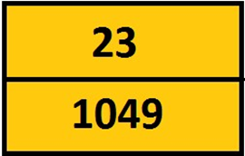

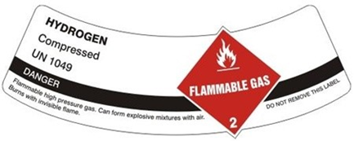

Essential resources

Localised resources. European Emergency Response Guide hydrogen dangers and specific tools Fire and Rescue Operational Sequence. Lecture 1: Introduction to hydrogen safety for responders
Annexe Operational Practice 1

Learning Outcomes, Assessment Criteria and Explanation

To pass this unit, the trainee needs to demonstrate that they can meet all the learning outcomes for the unit. The assessment criteria determine the standard required to achieve the unit.

Learning Outcomes |  | Assessment Criteria |  | Explanation
1 | Understand value of hydrogen |  | Written Examination |  | Knowledge
2 | Process of production |  | Written Examination |  | Knowledge

Unit 2 Hydrogen Properties

Objective

This unit is about the properties of hydrogen relevant to safety

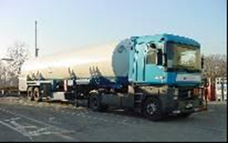

Essential resources

European Emergency Response Guide gaseous and liquid hydrogen fuel cells. Lecture 2: Properties of hydrogen relevant to safety Video Available 12

Learning Outcomes, Assessment Criteria and Explanation
To pass this unit, the trainee needs to demonstrate that they can meet all the learning outcomes for the unit. The assessment criteria determine the standard required to achieve the unit.

Learning Outcomes |  | Assessment Criteria |  | Explanation
1 | Specific physical properties |  | Written Examination |  | Knowledge
2 | Combustion characteristics |  | Written Examination |  | Knowledge
3 | Physiological hazards |  | Written Examination |  | Knowledge

Unit 3 Storage Arrangements

Objective

This unit is about hydrogen storage options – compressed, liquefied and in solid materials, as well as hazards and safety issues associated with them. Specifically catastrophic rupture of the vessels is introduces along with online tools which may be used.

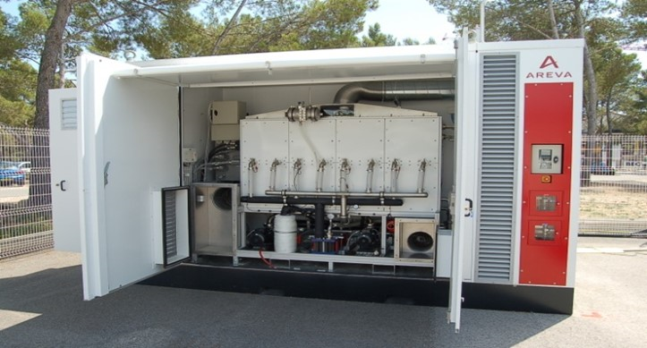

Essential resources

Localised resources and European Emergency Response Guide Hydrogen Dangers Electrolysers. Hydrogen storage Video Available 3-16-17

Learning Outcomes, Assessment Criteria and Explanation
To pass this unit, the trainee needs to demonstrate that they can meet all the learning outcomes for the unit. The assessment criteria determine the standard required to achieve the unit.

Learning Outcomes |  | Assessment Criteria |  |  | Explanation
 | States of storage |  | Oral Examination |  |  | Experience
 | Gaseous storage options |  | Oral Examination |  |  | Experience
 | Failure Devices |  | Oral Examination |  |  | Experience

Unit 4 Hydrogen Interactions

Objective

This unit is an overview of how hydrogen interacts with different types of materials and hydrogen permeation with relevance to hydrogen storage technologies.

HYDROGEN DANGERS

Odourless, colourless, tasteless, non-toxic, non-corrosive, highly flammable

Asphyxiation

Pressure
Pressurised up to 700 bar. Liquid to gas phase change 1 to 845

Noise
Gaseous hydrogen leak produces a noise that can reach 130-140dB

Embrittlement
Hydrogen is the smallest molecule of all known elements

Cryogenic
At ambient pressure, liquid hydrogen must be kept a 20.3°K (-252.85°C/-423.13ºF). Instantaneous cold burns.

Combustion

Essential resources

Localised resources and European Emergency Response Guide Fuel Cells. Compatibility of hydrogen with different materials. Video Available 4

Learning Outcomes, Assessment Criteria and Explanation

To pass this unit, the trainee needs to demonstrate that they can meet all the learning outcomes for the unit. The assessment criteria determine the standard required to achieve the unit.

Learning Outcomes |  | Assessment Criteria |  | Explanation
1 | Mechanisms and interactions |  | Oral Examination |  | Experience
2 | Embrittlement |  | Oral Examination |  | Experience

Unit 5 Liquefied Releases

Objective

This unit is about providing sufficient knowledge and the potential hazards of liquefied hydrogen to assist responders to understand the properties and behaviour of liquefied hydrogen.

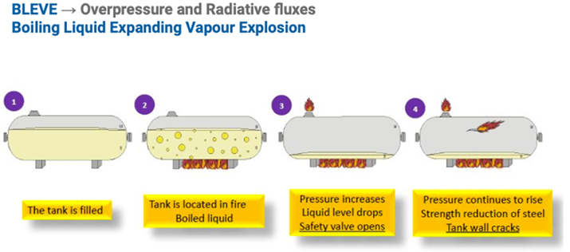

Essential resources

Localised resources and European Emergency Response Guide Liquid Hydrogen Fuel Cells. Safety of liquefied hydrogen Video Available 2
Annex Operational Practice 2

Learning Outcomes, Assessment Criteria and Explanation
To pass this unit, the trainee needs to demonstrate that they can meet all the learning outcomes for the unit. The assessment criteria determine the standard required to achieve the unit.

Learning Outcomes |  | Assessment Criteria |  | Explanation
1 | Properties of LH₂ |  | Written Examination |  | Knowledge
2 | Cryogenic hazards |  | Oral Examination |  | Experience
3 | Produce store transport |  | Oral Examination |  | Experience

Unit 6 Threat for people and property

Objective

This unit is about the impact of hydrogen leaks, fires and explosions on the health and environment of humans. It also considers the damage to structures and equipment caused by hydrogen fires and overpressure events.

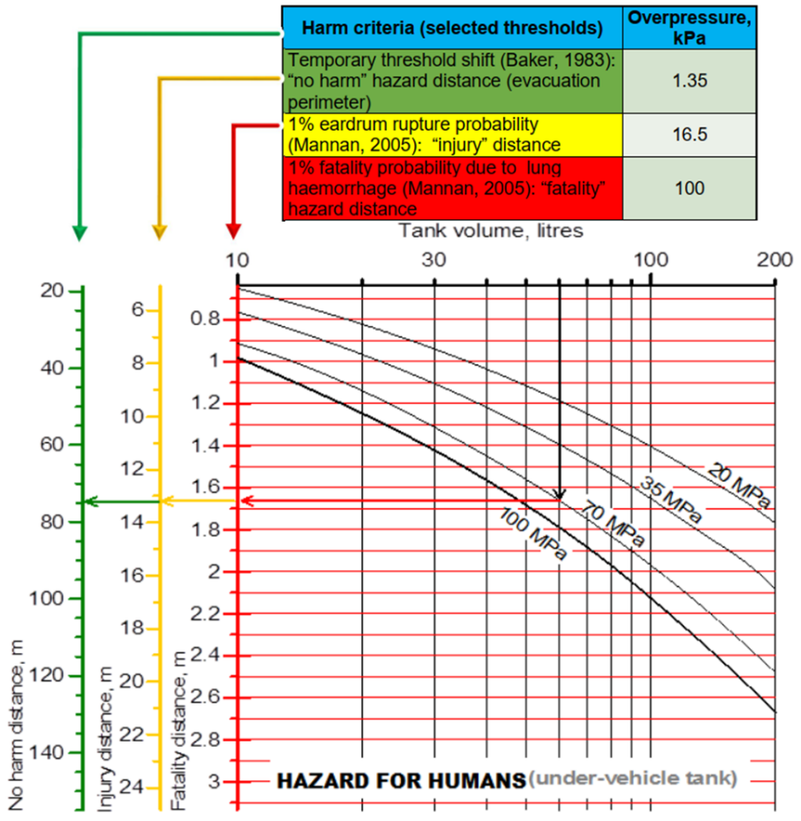

Essential resources

Localised resources and European Emergency Response Guide (Unit 9 Hazard distances). Harm criteria for people and property
Annexe Operational Practice 3

Learning Outcomes, Assessment Criteria and Explanation

To pass this unit, the trainee needs to demonstrate that they can meet all the learning outcomes for the unit. The assessment criteria determine the standard required to achieve the unit.

Learning Outcomes |  | Assessment Criteria |  | Explanation
1 | Hazards from releases |  | Written Examination |  | Knowledge
2 | Harmful effects on humans |  | Written Examination |  | Knowledge
3 | Criteria of harm |  | Written Examination |  | Knowledge

Unit 7 Ignited Releases and Prevention

Objective

This unit is about understanding hydrogen releases and mixing of escaped gas with air creating fire and explosion hazards associated with the escape of compressed gaseous hydrogen stored at high pressures at systems and infrastructure.

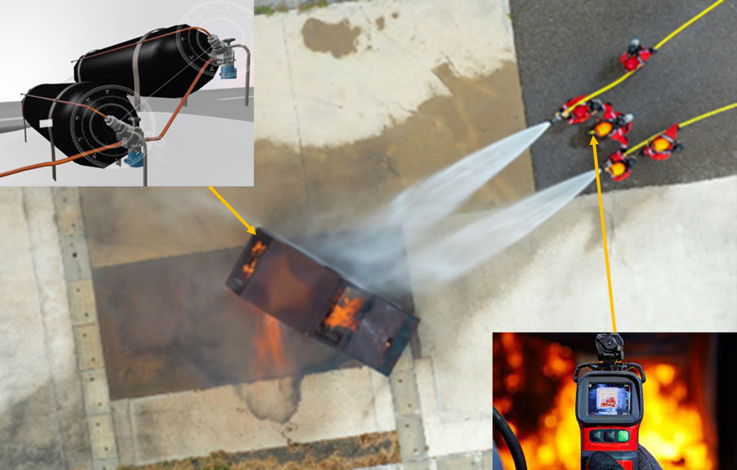

Essential resources

Localised resources and European Emergency Response Guide. Fuel Cells. Ignition sources and prevention of ignition. Video Available 6- 9 Annexe Operational Practice 5

Learning Outcomes, Assessment Criteria and Explanation

To pass this unit, the trainee needs to demonstrate that they can meet all the learning outcomes for the unit. The assessment criteria determine the standard required to achieve the unit.

Learning Outcomes |  | Assessment Criteria |  | Explanation
1 | Recognise vehicle impacts |  | Practical or VR Assessment |  | Skill

Unit 8 Unignited Releases

Objective
This unit is about providing an overview of hydrogen ignition incidents and mechanisms.

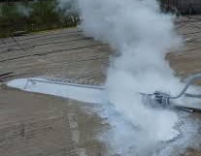

Essential resources

Localised resources and European Emergency Response Guide Fuel Cells. Unignited hydrogen releases outdoors and their mitigation Video Available 11.
Annexe Operational Practice 6

Learning Outcomes, Assessment Criteria and Explanation

To pass this unit, the trainee needs to demonstrate that they can meet all the learning outcomes for the unit. The assessment criteria determine the standard required to achieve the unit.

Learning Outcomes |  | Assessment Criteria |  | Explanation
1 | Ignition sources |  | Oral Examination |  | Experience
2 | Ignition mechanisms |  | Oral Examination |  | Experience
3 | Spontaneous ignition |  | Oral Examination |  | Experience

Unit 9 Hazard Distances

Objective
This unit is focused on ignited hydrogen releases with useful terminology to allow a classification of different types of hydrogen fires is provided

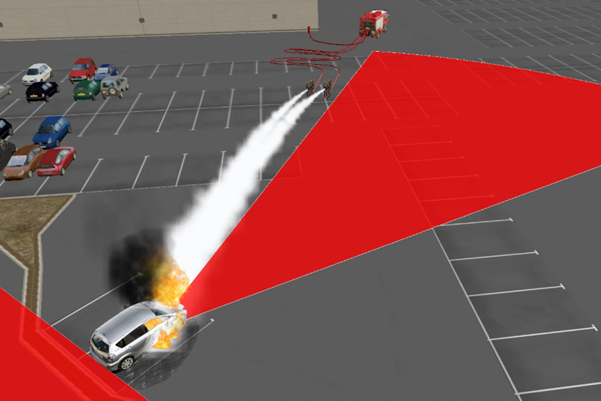

Essential resources

Localised resources and European Emergency Response Guide Nomograms Stand Alone Tank fire. Under vehicle fire Damage to Building. Hazard distances from hydrogen flames and firefighting
Annex Operational Practice 4

Learning Outcomes, Assessment Criteria and Explanation

To pass this unit, the trainee needs to demonstrate that they can meet all the learning outcomes for the unit. The assessment criteria determine the standard required to achieve the unit.

Learning Outcomes |  | Assessment Criteria |  | Explanation
1 | Identify different fire types |  | Written Examination |  | Knowledge
2 | Understand terminology |  | Written Examination |  | Knowledge

Unit 10 Explosions

Objective

This unit is about ‘chemical’ explosions, i.e. deflagrations and detonations, and ‘physical explosions’, i.e. tank ruptures.

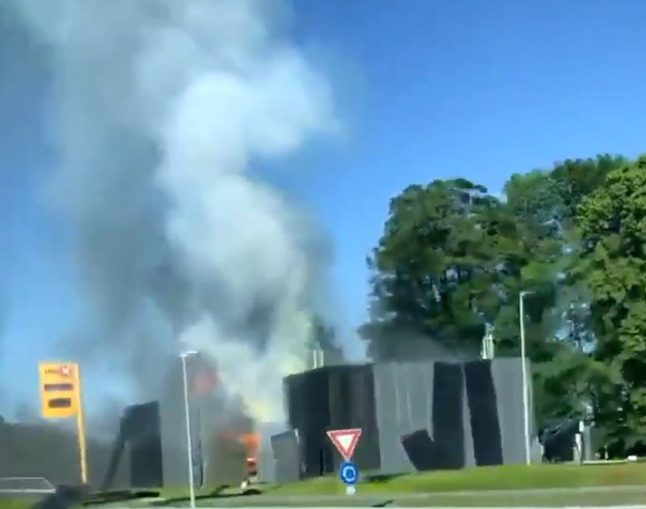

Essential resources

There are no special resources needed for this unit. Dealing with hydrogen explosions
Video Available 19

Learning Outcomes, Assessment Criteria and Explanation

To pass this unit, the trainee needs to demonstrate that they can meet all the learning outcomes for the unit. The assessment criteria determine the standard required to achieve the unit.

Learning Outcomes |  | Assessment Criteria |  | Explanation
1 | Effect of blast on buildings |  | Oral or VR Examination |  | Experience
2 | Effect of blast on people |  | Oral or VR Examination |  | Experience

Unit 11 Confined Spaces

Objective

This unit is about the use of fuel cells and hydrogen technologies in confined spaces, for example in e. g. indoors, in carparks and tunnels.

Essential resources

Localised resources and European Emergency Response Guide. Confined spaces Video Available 10

Learning Outcomes, Assessment Criteria and Explanation

To pass this unit, the trainee needs to demonstrate that they can meet all the learning outcomes for the unit. The assessment criteria determine the standard required to achieve the unit.

Learning Outcomes |  | Assessment Criteria |  | Explanation
1 | Effect of enclosures |  | Oral or VR Examination |  | Experience
2 | Enclosed spaces |  | Oral or VR Examination |  | Experience
3 | Indoor hydrogen fires |  | Oral or VR Examination |  | Experience

Unit 12 Refuelling Stations

Objective

This unit is about gaseous and liquid hydrogen storage based refuelling stations and associated infrastructure for hydrogen mobility.

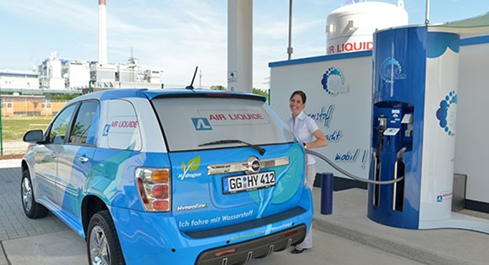

Essential resources

There are no special resources needed for this unit. Hydrogen refuelling stations & infrastructure

Learning Outcomes, Assessment Criteria and Explanation

To pass this unit, the trainee needs to demonstrate that they can meet all the learning outcomes for the unit. The assessment criteria determine the standard required to achieve the unit.

Learning Outcomes |  | Assessment Criteria |  | Explanation
1 | Filling stations equipment |  | Oral Examination |  | Experience

Unit 13 Standard Operating Practice

Objective

This unit is about recognising localised elements required for an operational protocol to respond and manage hydrogen emergencies

Thermal Imaging Cameras

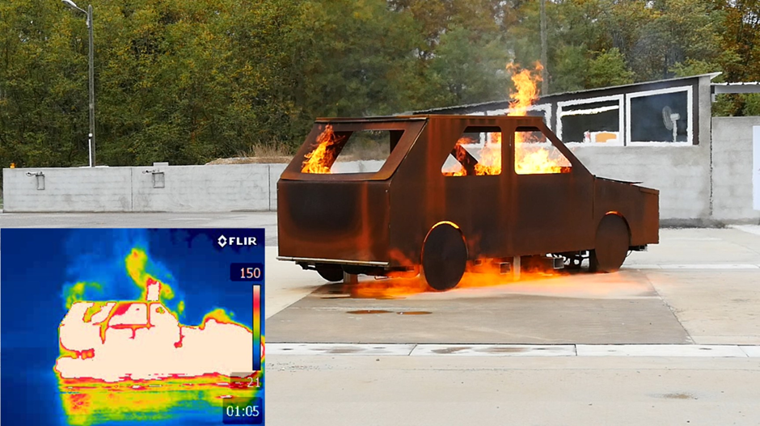

Essential resources

Localised materials and resources are needed for this unit. The objective is to set, using the learning from other units, the context of the local fire and rescue response to an operational emergency European Emergency Response Guide Strategy and Tactics. Ignited gaseous leaks Virtual Reality
Video Available 5

Learning Outcomes, Assessment Criteria and Explanation

To pass this unit, the trainee needs to demonstrate that they can meet all the learning outcomes for the unit. The assessment criteria determine the standard required to achieve the unit.

Learning Outcomes |  | Assessment Criteria |  | Explanation
1 | Relationship to local SOP |  | Practical Examination |  | Skill
2 | Prepared SOP for hydrogen |  | Practical Examination |  | Skill

Unit 14 Fuel Cell Vehicles

Objective

This unit is about understanding fuel cell arrangements in cars and vehicles

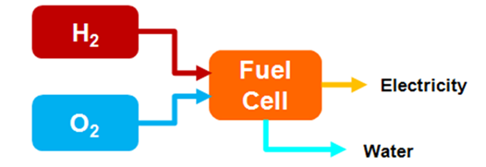
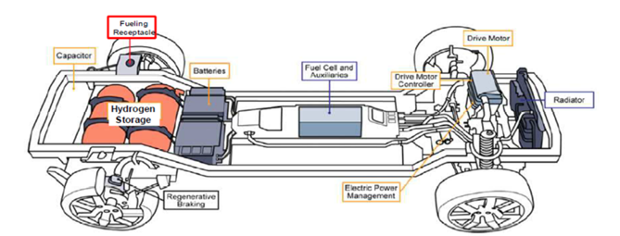

Essential resources

Operational video Single car burning in open grounds Single car burning in open grounds. Several cars (multi-energy) incident in tunnel Explosion in a FC container European Emergency Response Guide Fuel Cell Vehicles. Vehicles fires Virtual Reality
Video Available 7-8

Learning Outcomes, Assessment Criteria and Explanation

To pass this unit, the trainee needs to demonstrate that they can meet all the learning outcomes for the unit. The assessment criteria determine the standard required to achieve the unit.

Learning Outcomes |  | Assessment Criteria |  | Explanation
 | Tactical response |  | Practical Examination |  | Skill

Unit 15 Fuel Cell Buses

Objective

This unit is about understanding fuel cells on buses

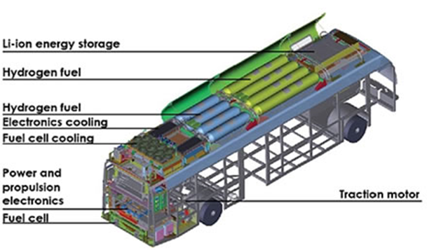

Essential resources

Video Bus Fire downtown European Emergency Response Guide Buses. Transportation Virtual Reality
Video Available 15

Learning Outcomes, Assessment Criteria and Explanation

To pass this unit, the trainee needs to demonstrate that they can meet all the learning outcomes for the unit. The assessment criteria determine the standard required to achieve the unit.

Learning Outcomes |  | Assessment Criteria |  | Explanation
 | Tactical response |  | Practical or VR Examination |  | Skill

Unit 16 Fuel Cell Trucks

Objective

This unit is about understanding fuel cells on trucks

Essential resources

Video H2 Bus Fire downtown H2 truck incident in commercial area (LH2 dump) Dismantled H2 trailer on motorway European Emergency Response Guide Trucks. Liquid hydrogen Virtual Reality
Video Available 13

Learning Outcomes, Assessment Criteria and Explanation

To pass this unit, the trainee needs to demonstrate that they can meet all the learning outcomes for the unit. The assessment criteria determine the standard required to achieve the unit.

Learning Outcomes |  | Assessment Criteria |  | Explanation
 | Tactical response |  | Practical or VR Examination |  | Skill

Unit 17 Fuel Cell Trains

Objective

This unit is about understanding fuel cells on trains

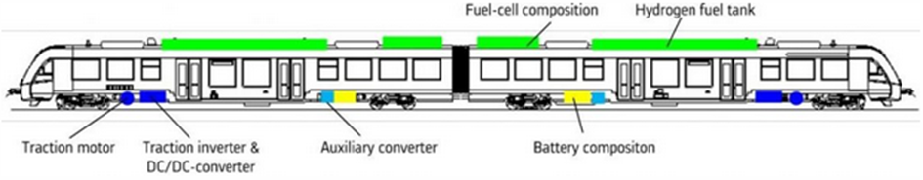

Essential resources

Video train fire in countryside European Emergency Response Guide Trains. Transportation Virtual Reality
Video Available 14

Learning Outcomes, Assessment Criteria and Explanation

To pass this unit, the trainee needs to demonstrate that they can meet all the learning outcomes for the unit. The assessment criteria determine the standard required to achieve the unit.

Learning Outcomes |  | Assessment Criteria |  | Explanation
 | Tactical response |  | Practical or VR Examination |  | Skill

Unit 18 Trailers

Objective

This unit is about understanding transportation in trailers

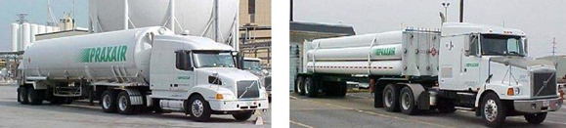

Essential resources

Operational video Bottle rack dispersion (dismantled rack and leak) European Emergency Response Guide Trailer. Small storage Virtual Reality
Video Available 18

Learning Outcomes, Assessment Criteria and Explanation

To pass this unit, the trainee needs to demonstrate that they can meet all the learning outcomes for the unit. The assessment criteria determine the standard required to achieve the unit.

Learning Outcomes |  | Assessment Criteria |  | Explanation
 | Tactical response |  | Practical or VR Examination |  | Skill

Unit 19 Industrial Refuelling Stations

Objective

This unit is about understanding arrangements at refuelling stations

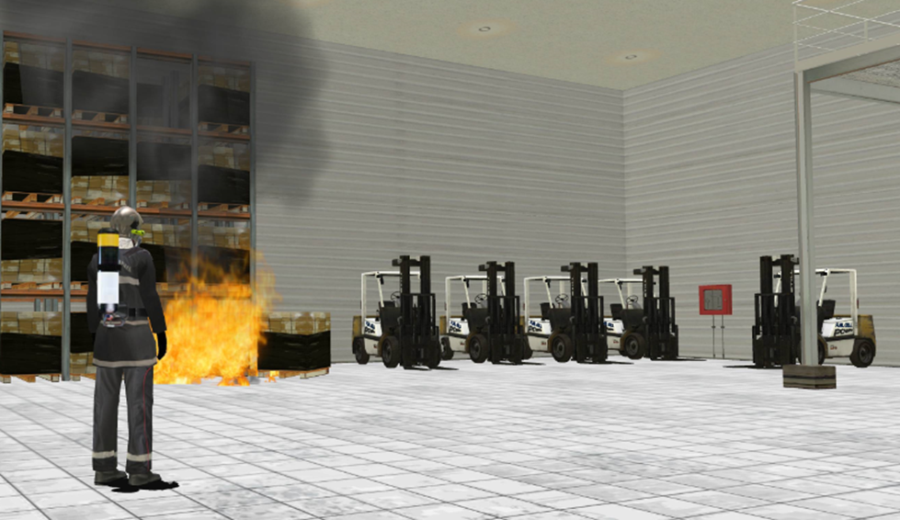

Essential resources

Video leak on the H2 feeding of a forklift station in a storage area European Emergency Response Guide refuelling Station. Explosion in a fuel cell enclosure Virtual Reality

Learning Outcomes, Assessment Criteria and Explanation

To pass this unit, the trainee needs to demonstrate that they can meet all the learning outcomes for the unit. The assessment criteria determine the standard required to achieve the unit.

Learning Outcomes |  | Assessment Criteria |  | Explanation
 | Tactical response |  | Practical or VR Examination |  | Skill

Unit 20 Generation Plant

Objective

This unit is about understanding arrangements at generation plant

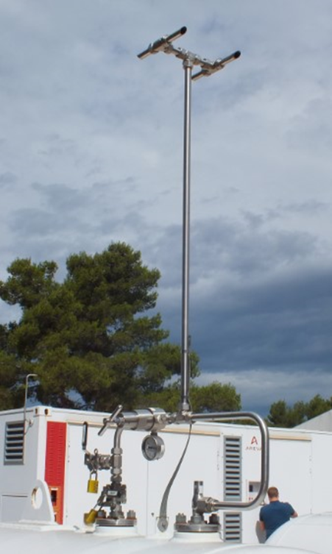

Essential resources

Video Ignited leak on the storages of a solar production site Sphere feed pipe leak in industrial storage (puddle) European Emergency Response Guide Stationary Power Generation Unit. Explosion in a fuel cell enclosure Virtual Reality
Video Available 1

Learning Outcomes, Assessment Criteria and Explanation

To pass this unit, the trainee needs to demonstrate that they can meet all the learning outcomes for the unit. The assessment criteria determine the standard required to achieve the unit.

Learning Outcomes |  | Assessment Criteria |  | Explanation
 | Tactical response |  | Practical or VR Examination |  | Skill

Operational Annex Contents
Operational Practice Notes 3
Operational Practice 1 3
FIRE ON THE ELECTRICAL COMPONENTS 3
Operational Practice 2 4
RESCUE 4
Operational Practice 3 5
IGNITED HYDROGEN LEAK 5
Operational Practice 4 6
EXTERNAL FIRE THREATENING Application or H2 storage 6
Operational Practice 5 8
IGNITED HYDROGEN LEAK 8
Operational Practice 6 10
UNIGNITED HYDROGEN LEAK 10
Tactical Notes 11
Tactic Number 1 FC CAR / FC FORKLIFT / FC BUS / FC TRUCKS / FC TRAINS / FC SHIP 11
NO LEAK NO FIRE (technical alarm, work accident, road traffic accident) 11
Tactic Number 2 FC CAR / FC FORKLIFT / FC BUS / FC TRUCKS / FC TRAINS / FC SHIP 13
H2 LEAK WITHOUT FIRE 13
Tactic Number 4 FC CAR / FC FORKLIFT / FC BUS / FC TRUCKS / FC TRAINS / FC SHIP 15
EXTERNAL FIRE THREATENING THE APPLICATION 15
Tactic Number 5 H2 (LH2) trailer 17
NO LEAK NO FIRE (technical alarm, work accident, road traffic accident) 17
Tactic Number 6 H2 trailer 19
H2 LEAK WITHOUT FIRE 19
Tactic Number 7 H2 trailer 21
FIRE 21
Tactic Number 8 H2 trailer 23
EXTERNAL FIRE THREATENING THE APPLICATION 23
Tactic Number 9 REFUELLING STATION 25
NO LEAK NO FIRE (technical alarm, work accident, road traffic accident) 25
Tactic 10 REFUELLING STATION 27
H2 LEAK WITHOUT FIRE 27
Tactic 12 REFUELLING STATION 29
EXTERNAL FIRE THREATENING THE APPLICATION 29
Stationary power generation unit (SPGU) / Hydrogen-based energy storage system (H2ESS) 31
Tactic 13 NO LEAK NO FIRE (technical alarm) 31
Stationary power generation unit (SPGU) / Hydrogen-based energy storage system (H2ESS) 33
Tactic 15 FIRE 33
Stationary power generation unit (SPGU) / Hydrogen-based energy storage system (H2ESS) 36
Tactic 16 EXTERNAL FIRE THREATENING THE APPLICATION 36

Intervention Strategy Notes

Operational Practice 1 RESCUE
Operational Practice 1
RESCUE
STEPS | ACTIONS | GOALS
RECOGNITION | IDENTIFY | - Contact the safety manager of the installation for the details of the incident and obtain site plan;  - Take into account the risk of explosion of hydrogen in confined spaces;  - Take into account the risk of anoxia in confined spaces.
RECOGNITION | PROHIBIT | - Prohibit the progress downwind. It is imperative to establish an exclusion zone of 50 m = evacuation;  - Prohibit the use of electrical or electronic devices in the non ATEX exclusion zone (cell phones, radios, etc.).
RECOGNITION | INSPECT | - Operate the external power cuts of the building
RESCUE | ACT  ISOLATE | -In case of hydrogen leak in confined spaces:  Wear a self-contained breathing apparatus  Remove the affected casualty outside the exclusion zone  - If risk of electrified or electrocuted victim  Use the electro-rescue equipment to remove the victim  Avoid contact of the first responders with electrical elements;
PREPAREDNESS/INCIDENT SETTLEMENT | ACT  ISOLATE | Confirm or refine exclusion zone (50 m)  Conduct surveys using an explosimeter (from top to bottom of the installation or storage facility)
PROTECTION | ACT  ISOLATE | - Actions to prevent a risk of anoxia:  • Close the hydrogen supply valves  • Ventilate the area by promoting the natural drawing (do not use electrical and thermal fans  Action on the electrical risk:  Press the emergency shutdown device of the installation (delay of 20 minutes with the presence of residual current)
CLEAR OUT  OVERHAUL | ACT  ISOLATE | The monitoring phase ceases as soon as: the oxygen level in the room is normal (about 20 vol. %)  Repeatedly check H2 presence in the atmosphere  • the electrical system is secure and supported by a technician

Operational Practice 2 FIRE ON THE ELECTRICAL COMPONENTS
Operational Practice 2
FIRE ON THE ELECTRICAL COMPONENTS
STEPS | ACTIONS | GOALS
RECOGNITION | IDENTIFY | - Contact the safety manager of the installation for the details of the incident, obtain site plan;  - - Take into account the “low voltage” hazards
RECOGNITION | PROHIBIT | - Prohibit downwind progression and imperatively establish an exclusion zone of 50 m = evacuation;  - Prohibit the use of non ATEX electrical or electronic devices in the exclusion zone (cell phones, radios, etc.).
RECOGNITION | INSPECT | - Operate the external power cuts of the building;
RESCUE | ACT  ISOLATE | - In case of hydrogen in confined spaces:  - Wear a breathing apparatus  - Remove the affected person outside the exclusion zone  - Administer medical support  - If risk of electrified or electrocuted victim  - Use the electro-rescue equipment to remove the victim  - Avoid contact of the first responders with electrical elements  - Request specialist support
PREPAREDNESS  INCIDENT SETTLEMENT | ACT  ISOLATE | - Confirm or refine exclusion zone (50 m) (based on the sound of a leak under pressure, readings of explosimeter, etc.);  - Proceed to the extinction of the flame based on its virulence:  - With a powder or CO2 fire extinguisher at a distance more than > 1m  - with variable flow-rate nozzles in, spray attack pulse at a distance of more than 3m
PROTECTION | ACT  ISOLATE | - Press the emergency shutdown device installation (20 minutes from time with the presence of a residual current);  - Take into account the flow of water during the timeout shutdown phase of the installation (electrical hazard);  - Close hydrogen supply valves;  - Ventilate premises facilitating natural drawing (opening existing outlets).
CLEAR OUT  OVERHAUL | ACT  ISOLATE | - Look for high temperature points on hydrogen storage using thermal imaging device on Hydrogen storage (UAV for example if available);  - The monitoring phase ends when it is found that the actions aimed at extinguishing measures proved effective.

Operational Practice 3 EXTERNAL FIRE THREATENING Application or H2 storage
Operational Practice 3
EXTERNAL FIRE THREATENING Application or H2 storage
STEPS | ACTIONS | GOALS
RECOGNITION | IDENTIFY | Contact the safety manager of the installation for the details of the incident, obtain site plan;  - Take into account the risk of explosion of a hydrogen tanks under fire, with projections (several tens of meters for bottles to several hundred for trailers).
RECOGNITION | PROHIBIT | - Prohibit the progress downwind and imperative to establish an exclusion zone of 50 m = evacuation;  - Prohibit the use of non ATEX electrical or electronic devices in the exclusion zone (cell phones, radios, etc.).
RECOGNITION | INSPECT | - Operate the external power cuts of the building;
RESCUE | ACT  ISOLATE | - In case of hydrogen in confined spaces:  - Wear a breathing apparatus  - Remove the affected person/victim outside the exclusion zone  - Administer medical support  - If risk of electrified or electrocuted victim  - Use the electro-rescue equipment to remove the victim  - Avoid contact with electrical stakeholder bodies  - Request specialist support
PREPAREDNESS/  INCIDENT SETTLEMENT | ACT  ISOLATE | - Confirm or refine the exclusion zone (tanks or Installation directly threatened by the flames);  - Proceed with the extinction of fires  - Provide preventive cooling of the facilities and hydrogen storage in the following ways:  - Establishment of a "peacock tail “type nozzle  - Direct attack spread water jet on the hydrogen tanks using with variable flow-rate nozzles spear 250l/min minimum (avoid directing the jets on pipes)  - establishment of spread water jet for the protection of sensitive point (power Bay ....)
PROTECTION | ACT  ISOLATE | Press the emergency shutdown device (20 minutes from time with the presence of a residual current);  - Close hydrogen supply valves;  - Ventilate premises facilitating natural drawing (opening existing outlets).
CLEAR OUT  OVERHAUL | ACT  ISOLATE | - Look for high temperature points on hydrogen storage using thermal imaging device on hydrogen storage (UAV for example if available);  -The monitoring phase ends when it is found that  - actions aimed at extinguishing proved effective.  - the water spread on the hydrogen tanks do not evaporate on contact with surfaces

Operational Practice 4 IGNITED HYDROGEN LEAK
Operational Practice 4
IGNITED HYDROGEN LEAK
STEPS | ACTIONS | GOALS
RECOGNITION | IDENTIFY | - Contact the safety manager of the installation for the details of the incident, obtain site plan;  - Take into account the dispersion of H₂ in premises before the ignition (possibility of UVCE unconfined vapour cloud explosion).
RECOGNITION | PROHIBIT | - Prohibit downwind progression and imperatively establish an exclusion zone of 50 m = evacuation;  - Prohibit the use of non ATEX electrical or electronic devices in the exclusion zone (cell phones, radios, etc.).  - Prohibit the extinguishment of the hydrogen flames.  - - Prohibit the actions on the electrical system of the facility in case of hydrogen leak.
RECOGNITION | INSPECT | - Operate the external power cuts of the building  - Confirm the presence of an ignited leak ghost and its length using thermal camera (hardly visible flame in its entirety, in the day light);  - - Pay attention to the significant sound of an ignite gas leak.
RESCUE | ACT  ISOLATE | In case of hydrogen in confined spaces:  - Wear a breathing apparatus  - Remove the affected person(s) outside the exclusion zone  - Administer medical assistance  If risk of electrified or electrocuted victim  - Use the electro-rescue equipment to remove the victim  - Avoid contact with electrical stakeholder bodies  - Seek specialist support
PREPAREDNESS  INCIDENT SETTLEMENT | ACT  ISOLATE | - Refine the exclusion area (explosimeter measurements, information on the nature of the incident ...);  - Set up water curtains to prevent a fire spread;  - - If necessary, provide preventive cooling on hydrogen storage and facilities nearby.
PROTECTION | ACT  ISOLATE | - Close hydrogen supply valves;  - Ventilate premises facilitating natural drawing (opening existing outlets).
CLEAR OUT  OVERHAUL | ACT  ISOLATE | - Look for high temperature points on hydrogen storage using thermal imaging device on Hydrogen storage (UAV for example if available);  - Conduct surveys of explosimeter in confined spaces prioritizing high points;  - Press the emergency shutdown device of the installation (delay of 20 minutes with the presence of a residual current).

Operational Practice 5 IGNITED HYDROGEN LEAK
Operational Practice 5
IGNITED HYDROGEN LEAK
STEPS | ACTIONS | GOALS
RECOGNITION | IDENTIFY | - Contact the safety manager of the installation for the details of the incident, obtain site plan;  - Take into account the dispersion of H₂ in premises before the ignition (possibility of UVCE unconfined vapour cloud explosion).
RECOGNITION | PROHIBIT | - Prohibit downwind progression and imperatively establish an exclusion zone of 50 m = evacuation;  - Prohibit the use of non ATEX electrical or electronic devices in the exclusion zone (cell phones, radios, etc.).  - Prohibit the extinguishment of the hydrogen flames.  - Prohibit the actions on the electrical system of the facility in case of hydrogen leak.
RECOGNITION | INSPECT | - Operate the external power cuts of the building  - Confirm the presence of an ignited leak ghost and its length using thermal camera (hardly visible flame in its entirety, in the day light);  - Pay attention to the significant sound of an ignite gas leak.
RESCUE | ACT  ISOLATE | - In case of hydrogen in confined spaces:  Wear a breathing apparatus  Remove the affected person(s) outside the exclusion zone  Administer medical assistance  If risk of electrified or electrocuted victim  Use the electro-rescue equipment to remove the victim  Avoid contact with electrical stakeholder bodies  Seek specialist support
PREPAREDNESS/INCIDENT SETTLEMENT | ACT  ISOLATE | Refine the exclusion area (explosimeter measurements, information on the nature of the incident ...);  Set up water curtains to prevent a fire spread;  If necessary, provide preventive cooling on hydrogen storage and facilities nearby.
PROTECTION | ACT  ISOLATE | Close hydrogen supply valves;  Ventilate premises facilitating natural drawing (opening existing outlets).
CLEAR OUT  OVERHAUL | ACT  ISOLATE | Look for high temperature points on hydrogen storage using thermal imaging device on Hydrogen storage (UAV for example if available);  Conduct surveys of explosimeter in confined spaces prioritizing high points;  Press the emergency shutdown device of the installation (delay of 20 minutes with the presence of a residual current).

Operational Practice 6 UNIGNITED HYDROGEN LEAK
Operational Practice 6
UNIGNITED HYDROGEN LEAK
STEPS | ACTIONS | GOALS
RECOGNITION | IDENTIFY | - Contact the safety manager of the installation for the details on the incident, obtain site plan;  - Take into account the risk of explosion
 | PROHIBIT | - Prohibit downwind progression and imperatively establish an exclusion zone of 50 m = evacuation;  - Prohibit the use of non ATEX electrical or electronic devices in the exclusion zone (cell phones, radios, etc.).  - Prohibit the actions on the electrical system of the facility in case of hydrogen leak.
 | INSPECT | - Operate the external power cuts of the building
RESCUE | ACT  ISOLATE | - In case of hydrogen in confined spaces:  - Wear a breathing apparatus  - Remove the affected person (s) outside the exclusion zone  - Administer medical assistance  - If risk of electrified or electrocuted victim  - Use the electro-rescue equipment to remove the victim  - Avoid contact with electrical stakeholder bodies  - Seek specialist support
PREPAREDNESS/  INCIDENT SETTLEMENT | ACT  ISOLATE | - Refine the security area based explosimeter measurements (from top to bottom of the installation);  - Close hydrogen supply valves;  - Ventilate premises facilitating natural drawing (opening existing outlets).
PROTECTION | ACT  ISOLATE
CLEAR OUT  OVERHAUL | ACT  ISOLATE | - The monitoring phase ends when there is no risk of explosion in a secure area (complete emptying of the tank or draining in open air in a secure area monitored by the operator, efficient ventilation of the premises)  - Press the electrical emergency shutdown device of the installation (delay of 20 minutes with the presence of a residual current)
Note: the action on the emergency shutdown device during the overhaul phase, clears electric ignition sources, intrinsic with the installation.

Tactical Notes
Important notice: Remember that the casting distances are INDICATIVE.

The incident commander must enlarge or reduce the safety perimeter, taking into account the reality of the situation and in particular, the capacity of the H₂, LH₂ (or O₂) tank concerned.

Tactic 1 FC CAR / FC FORKLIFT / FC BUS / FC TRUCKS / FC TRAINS / FC SHIP NO LEAK NO FIRE (technical alarm, work accident, road traffic accident)
 | FC CAR / FC FORKLIFT / FC BUS / FC TRUCKS / FC TRAINS / FC SHIP | 
Tactic Number 1 | NO LEAK NO FIRE  (technical alarm, work accident, road traffic accident)
AT THE FIRE STATION
TAKE USEFUL information ABOUT THE INCIDENT
- Assure the precise incident location (may include using vehicle tracking)
- Are there any person involved in the incident?
- Type of vehicle concerned with manufacturer’s emergency response guidance
- What happened?

TAKE USEFUL INFORMATION ABOUT THE METEOROLOGICAL SITUATION
- Wind direction
- Wind speed

ITINERARY, choose a safe itinerary
- Do not cross an eventual explosive gas cloud
- Do not reach scene from bellow
- Anticipate the need of a hydrant

TAKE FOLLOWING TOOLS (if available use drone UAV)
- Gaseous hydrocarbons detector
- H2 detector
- O2 detector
- Thermal imaging camera
ARRIVAL ON SCENE
ARRIVAL
- Choose a safe way to get to the incident ground, preventing the fire appliance to cross a flammable gas cloud, and make sure to arrive upwind
- Stop the fire appliance 50 meters before the incident
- Away from a possible ignited flammable liquid leak progression distance
- Engage the pump and connect the fire appliance to a hydrant

SAFETY AREA
- Set up a safety area for the public beyond a radius of 50 meters
- Ensure that unauthorized/untrained personnel do not enter the hazardous area

SIZE UP THE SCENE
QUESTION WITNESSES AND OBSERVE, SEEK ANSWERS TO THE FOLLOWING QUESTIONS
- What type of vehicle is affected?
- What happened?
- Vehicle gas tank size and content in litres
- Is someone injured? Threatened?
- Has a leak occurred? Is a leak still occurring?
- Is a part of the vehicle damaged?

Check energies present in the involved vehicle (tank type, refueling hose type, vehicle registration papers...)
Identify Vehicle (H2 car may be identified by FCHV Fuel Cell Hybrid Vehicle badges)
Operate H2 detector

RESCUE
Rescue of humans override all but personal safety considerations

Engage rescue as a conventional accident with hazmat support

EXPOSURE PROTECTION
- Use only necessary personnel
- Open the doors and hoods (if present)
- Set parking brake
- Wedge the vehicle
- Turn off the ignition key
- Press the fuel cell emergency shutdown device
- For bus, an emergency shutdown device is generally located near the driver seat on left side and another is on fuel cell in "engine" compartment, located at the back of the bus.
- For trucks, trains and ships: safety data sheets or on-board rescue sheet
- If it's not possible to reach Ignition key, remove all the fuses in the fuse boxes and then, cut the negative low voltage battery cable (12 or 24V) taking care not to create an ignition spark
- Repeatedly check H2 presence in the atmosphere. If H2 is detected apply H2 leak tactic
- Check if high temperature points exist on the vehicle (more than 150°C/302°F)
- Stretch a fire hose line to protect the action of teams

INCIDENT TREATMENT
If no H2 leak and no sign of fire is detected
- Engage incident settlement following manufacturers Emergency Response Guides

DO NOT
- Cut or crush H2 lines
- Cut or crush High Voltage Lines (orange)
- Damage H2 tank
- Damage traction Battery Stack
If a H2 leak is detected, apply tactic n°2 "H2 LEAK WITHOUT FIRE"
OVERHAUL
After a last H2 atmospheric control, make sure that the vehicle or the wreckage is evacuated by authorised personnel (ideally manufacturer)

Tactic 2 FC CAR / FC FORKLIFT / FC BUS / FC TRUCKS / FC TRAINS / FC SHIP H2 LEAK WITHOUT FIRE
 | FC CAR / FC FORKLIFT / FC BUS / FC TRUCKS / FC TRAINS / FC SHIP
Tactic Number 2 | H2 LEAK WITHOUT FIRE
AT THE FIRE STATION
TAKE USEFUL information ABOUT THE INCIDENT
- Assure the precise incident location (may include using vehicle tracking)
- Are there any person involved in the incident?
- Type of vehicle concerned with manufacturer’s emergency response guidance
- What happend?

TAKE USEFUL INFORMATION ABOUT THE METEOROLOGICAL SITUATION
- Wind direction
- Wind speed

ITINERARY, choose a safe itinerary
- Do not cross an eventual explosive gas cloud
- Do not reach scene from bellow
- Anticipate the need of a hydrant

TAKE FOLLOWING TOOLS (if availble use drone UAV)
- Gaseous hydrocarbons detector
- H2 detector
- O2 detector
- Thermal imaging camera
ARRIVAL ON SCENE
ARRIVAL
- Choose a safe way to get to the incident ground, preventing the fire appliance to cross a flammable gaz cloud, and make sure to arrive upwind
- Stop the fire appliance 50 meters before the incident
- Away from a possible ignited flammable liquid leak progression
- Engage the pump and connect the fire appliance to a hydrant

SAFETY AREA
- CAR and FORKLIFT Set up a safety area for the public beyond a radius of 100 meters
- BUS, truck, train, ship: Set up a safety area for the public beyond a radius of 200 meters
- Ensure that unauthorized/untrained personnel do not enter the hazardous area

SIZE UP THE SCENE
IF A PERSON IS INSIDE THE HAZARDOUS AREA, ENGAGE RESCUE OPERATIONS
IF NO ONE IS INSIDE THE HAZARDOUS AREA, answer the following questions
- What type of vehicle is affected?
- What happened?
- Vehicle gas tank size and content in litres
- Has a loud hissing sound been eared before the FR arrive?

Vehicle identification, H2 car may be identified by FCHV Fuel Cell Hybrid Vehicle badges

Confirm the safety area with the H2 detector
If H2 is detected, refine the safety area
Check if high temperature points exist on the vehicle (more than 150°C/302°F)
RESCUE
Rescue of humans override all but personal safety considerations
Engage rescue as a conventional accident with hazmat support, if a human is threatened or concerned by the gas leak
• Team 1: extract the victim(s) from the danger zone by any possible means
• Team 2: stretch a fire hoseline to protect the action of the team 1 in case of an ignition of the cloud

Evacuate the passengers in the opposite direction of the wind
EXPOSURE PROTECTION
Use only necessary personnel
Evacuate adjacent buildings
If the vehicle is in a building, prevent H2 accumulation by operating wide ventilation of the building
Open the doors and hoods (if present)
Set parking brake
Wedge the vehicle
Turn off the ignition key
Press the fuel cell emergency shutdown device
For busses, an emergency shutdown device is generaly located near the driver seat on left side and another is on fuel cell in "engine" compartment, located at the back of the bus.
For trucks, trains and ships: safety data sheets or on-board rescue sheet
Do not operate any other electrical breaker to avoid creation of electrical spark
Repeatedly check H2 presence in the atmosphere
Refine safety area
Check if high temperature points exist on the vehicle (more than 150°C/302°F)

INCIDENT TREATMENT
If H2 Leak still exist after "exposure protection step "anf if it exists, close H2 valve as close as possible of the H2 tank
If it is not possible to reach a H2 valve, allow H2 to leak safely until the tank is empty

OVERHAUL
After a last H2 atmospheric control, Make sure that the vehicle or the wreckage is evacuated by authorized personnels (idealy manufacturer)

Tactic 3 FC CAR / FC FORKLIFT / FC BUS / FC TRUCKS / FC TRAINS / FC SHIP FIRE
 | FC CAR / FC FORKLIFT / FC BUS / FC TRUCKS / FC TRAINS / FC SHIP
Tactic n° 3 | FIRE
AT THE FIRE STATION
TAKE USEFUL information ABOUT THE INCIDENT
- Assure the precise incident location (may include using vehicle tracking)
- Are there any person involved in the incident?
- Type of vehicle concerned with manufacturer’s emergency response guidance
- What happend?

TAKE USEFUL INFORMATION ABOUT THE METEOROLOGICAL SITUATION
- Wind direction
- Wind speed

ITINERARY, choose a safe itinerary
- Do not cross an eventual explosive gas cloud
- Do not reach scene from bellow
- Anticipate the need of a hydrant

TAKE FOLLOWING TOOLS (if availble use drone UAV)
- Gaseous hydrocarbons detector
- H2 detector
- O2 detector
- Thermal imaging camera
ARRIVAL ON SCENE
ARRIVAL
- Choose a safe way to get to the incident ground, preventing the fire appliance to cross a flammable gaz cloud, and make sure to arrive upwind
- Stop the fire appliance 50 meters before the incident
- Away from a possible ignited flammable liquid leak progression
- Engage the pump and connect the fire appliance to a hydrant
SAFETY AREA
- CAR and FORKLIFT Set up a safety area for the public beyond a radius of 100 meters
- BUS, truck, train, ship:Set up a safety area for the public beyond a radius of 200 meters
- Ensure that unauthorized/untrained personnel do not enter the hazardous area
SIZE UP THE SCENE
IF A PERSON IS INSIDE THE HAZARDOUS AREA, ENGAGE RESCUE OPERATIONS then answer the following questions
- Is someone threatened by the fire? Where?
- How many vehicles are involved in the fire?
- How many of these vehicles are powered by H2 or another compressed flammable Gaz?
- Has a loud hissing sound been eared before the FR arrive?
Vehicle identification, H2 car may be identified by FCHV Fuel Cell Hybrid Vehicle badges
RESCUE
Rescue of humans override all but personal safety considerations
Engage rescue as a conventional accident with hazmat support, if a human is threatened or concerned by the fire
• Team 1: extract the victim(s) from the danger zone by any possible means
• Team 2: stretch a fire hoseline to protect the action of the team 1
Evacuate the passengers in the opposite direction of the wind
EXPOSURE PROTECTION
Use only necessary personnel
Evacuate adjacent buildings
Prevent the fire from spreading to a uninvolved vehicle(s) or building(s)
Move ajacent non involved vehicles by any way possible (driving, towing, pushing…)
If the vehicle is in a building, prevent combustion gases and H2 accumulation by operating wide ventilation of the building

Open the doors and hoods (if present)
Set parking brake
Wedge the vehicle
Turn off the ignition key
Press the fuel cell emergency shutdown device
For buses, an emergency shutdown device is generaly located near the driver seat on left side and another is on fuel cell in "engine" compartment, located at the back of the bus.
For trucks, trains and ships: safety data sheets or on-board rescue sheet

Repeatedly check H2 presence in the atmosphere
Refine safety area
Repeatedly check H2 tanks temperature with thermal imaging device
INCIDENT TREATMENT
In case of High stake level situation, operate an offensive fire attack, each team prepare 80 m of hoselines directly connected to the fire appliance pump
• Team 1: aims to cool the H2 tank and so doing prevent Thermal Pressure Release Device to operate
• Team 2: aims to extiguish the vehicle fire

The teams avoid passing through danger angles

Mind that violent reactions are possible between water and burning materials
as soon as possible, wedge the vehicle

Mind that water will be polluted during extinction (especialy if battery is damaged.), operate its containement

In there is no identified stake, evaluate the opportunity to let the vehicle burn safely

OVERHAUL
• Cool the wreckage as soon as no heat point is detected by the thermal imaging device
• After a last H2 atmospheric control, Make sure that the vehicle or the wreckage is evacuated by authorized personnels (idealy manufacturer)

Tactic 4 FC CAR / FC FORKLIFT / FC BUS / FC TRUCKS / FC TRAINS / FC SHIP EXTERNAL FIRE THREATENING THE APPLICATION

 | FC CAR / FC FORKLIFT / FC BUS / FC TRUCKS / FC TRAINS / FC SHIP
Tactic Number 4 | EXTERNAL FIRE THREATENING THE APPLICATION
AT THE FIRE STATION
TAKE USEFUL information ABOUT THE INCIDENT
- Assure the precise incident location (may include using vehicle tracking)
- Are there any person involved in the incident?
- Type of vehicle concerned with manufacturer’s emergency response guidance
- What happend?

TAKE USEFUL INFORMATION ABOUT THE METEOROLOGICAL SITUATION
- Wind direction
- Wind speed

ITINERARY, choose a safe itinerary
- Do not cross an eventual explosive gas cloud
- Do not reach scene from bellow
- Anticipate the need of a hydrant

TAKE FOLLOWING TOOLS (if availble use drone UAV)
- Gaseous hydrocarbons detector
- H2 detector
- O2 detector
- Thermal imaging camera
ARRIVAL ON SCENE
ARRIVAL
- Choose a safe way to get to the incident ground, preventing the fire appliance to cross a flammable gaz cloud, and make sure to arrive upwind
- Stop the fire appliance 50 meters before the incident
- Away from a possible ignited flammable liquid leak progression
- Engage the pump and connect the fire appliance to a hydrant

SAFETY AREA
- CAR and FORKLIFT Set up a safety area for the public beyond a radius of 100 meters
- BUS, truck, train, ship: Set up a safety area for the public beyond a radius of 200 meters (220 yd)
- Ensure that unauthorized/untrained personnel do not enter the hazardous area

SIZE UP THE SCENE
Answer the following questions
- What is burning?
- What's the fire strength?
- What's the distance between the fire and the FCH vehicle?
- Is someone injured? Threatened?
- Has a leak occured? Is a leak still occuring?

RESCUE
Rescue of humans override all but personal safety considerations

Engage rescue as a conventional accident with hazmat support.

If a human is threatened or concerned by the fire
- Team 1: extract the victim(s) from the danger zone by any possible means
- Team 2: stretch a fire hoseline to protect the action of the team 1

Evacuate the passengers in the opposite direction of the wind

EXPOSURE PROTECTION
Team 1: attenuate the radiant heat by providing a water spray curtain between the fire and the FCH vehicle.

INCIDENT TREATMENT
Operate an defensive fire attack, each team prepare 80 m of hoselines directly connected to the fire appliance pump
• Team 1: attenuate the radiant heat by providing a water spray curtain between the fire and the FCH vehicle
• Team 2: put out the fire with water, foam or powder depending what is burning

If putting fire out is not possible, or if enouth personnel is available, move the FCH vehicle by any way possible (driving, towing, pushing…) away from the radiant effect of the fire

OVERHAUL
Check temperature on the FCH vehicle with thermal imaging device

Tactic 5 H2 (LH2) Trailer NO LEAK NO FIRE (technical alarm, work accident, road traffic accident)
 | H2 (LH2) trailer
Tactic Number 5 | NO LEAK NO FIRE  (technical alarm, work accident, road traffic accident)
AT THE FIRE STATION
TAKE USEFUL information ABOUT THE INCIDENT
- Assure the precise incident location (may include using vehicle tracking)
- Are there any person involved in the incident?
- Type of vehicle concerned with manufacturer’s emergency response guidance
- What happend?

TAKE USEFUL INFORMATION ABOUT THE METEOROLOGICAL SITUATION
- Wind direction
- Wind speed

ITINERARY, choose a safe itinerary
- Do not cross an eventual explosive gas cloud
- Do not reach scene from bellow
- Anticipate the need of a hydrant

TAKE FOLLOWING TOOLS (if availble use drone UAV)
- Gaseous hydrocarbons detector
- H2 detector
- O2 detector
- Thermal imaging camera
ARRIVAL ON SCENE
ARRIVAL
- Choose a safe way to get to the incident ground, preventing the fire appliance to cross a flammable gaz cloud, and make sure to arrive upwind
- Stop the fire appliance 50 meters before the incident
- Away from a possible ignited flammable liquid leak progression
- Engage the pump and connect the fire appliance to a hydrant

SAFETY AREA
- Set up a safety area for the public beyond a radius of 50 meters
- Ensure that unauthorized/untrained personnel do not enter the hazardous area
SIZE UP THE SCENE
BY QUESTIONNING THE WITNESSES AND OBSERVATION, ANSWER THE FOLLOWING QUESTIONS
- Which Type is the involved vehicle?
- What has happened?
- Is someone injured? Threatened?
- Has a leak occured? Is a leak still occuring?
- Is a part of the truck damaged?
- Is the trailer dismanteled?
Check energies present in the involved vehicle (tank type, refuelling hole type, vehicle registration papers...)
Does a flammable liquid leak exists?
Operate H2 detector

RESCUE
Rescue of humans override all but personal safety considerations
Engage rescue as a conventional accident with hazmat support
EXPOSURE PROTECTION
Use only necessary personnel
Set parking brake
Wedge the vehicle
Turn off the ignition key

Repeatedly check H2 presence in the atmosphere. If H2 is detected apply H2 leak tactic
Check if high temperature points exist on the vehicle (more than 150°C/302°F)
Stretch a fire hoseline to protect the action of other teams

INCIDENT TREATMENT
Check and close every H2 valve on the trailer
If no H2 leak and no sign of fire is detected, engage incident settlement following usual road trafic accident and extrication guidelines

DO NOT
- cut or crush H2 lines
- damage H2 tanks

If the trailer is dimanteled, inspect individualy each cylinder, contact the transport company hotline to evacuate safely the cylinders

OVERHAUL
After a last H2 atmospheric control, make sure that the vehicle or the wreckage and the cargo is evacuated by authorized personnels (idealy transport company

Tactic 6 H2 Trailer H2 LEAK WITHOUT FIRE

 | H2 trailer
Tactic Number 6 | H2 LEAK WITHOUT FIRE
AT THE FIRE STATION
TAKE USEFUL information ABOUT THE INCIDENT
- Assure the precise incident location (may include using vehicle tracking)
- Are there any person involved in the incident?
- Type of vehicle concerned with manufacturer’s emergency response guidance
- What happend?
- Type of trailer concerned? Size, full or empty?
- Is the cargo dismanteled?

TAKE USEFUL INFORMATION ABOUT THE METEOROLOGICAL SITUATION
- Wind direction
- Wind speed

ITINERARY, choose a safe itinerary
- Do not cross an eventual explosive gas cloud
- Do not reach scene from bellow
- Anticipate the need of a hydrant

TAKE FOLLOWING TOOLS (if availble use drone UAV)
- Gaseous hydrocarbons detector
- H2 detector
- O2 detector
- Thermal imaging camera
ARRIVAL ON SCENE
ARRIVAL
- Choose a safe way to get to the incident ground, preventing the fire appliance to cross a flammable gaz cloud, and make sure to arrive upwind.
- Stop the fire appliance 50 meters before the incident
- Away from a possible ignited flammable liquid leak progression
- Engage the pump and connect the fire appliance to a hydrant.

SAFETY AREA
- Set up a safety area for the public beyond a radius of 100 meters
- Ensure that unauthorized/untrained personnel do not enter the hazardous area
SIZE UP THE SCENE
IF A PERSON IS INSIDE THE HAZARDOUS AREA, ENGAGE RESCUE OPERATIONS
IF NO ONE IS INSIDE THE HAZARDOUS AREA, BY QUESTIONNING THE WITNESSES (DRIVER) AND OBSERVATION, ANSWER THE FOLLOWING QUESTIONS
- Which Type is the involved vehicle?
- What happened?
- Is the trailer dismanteled?
- Has a loud hissing sound been eared before the FR arrive?

Confirm the safety area with the H2 detector . If H2 is detected, refine the safety area
Check if high temperature points exist on the vehicle (more than 150°C/302°F)

RESCUE
Rescue of humans override all but personal safety considerations
Engage rescue as a conventional accident with hazmat support
If a human is threatened or concerned by the gas leak
- Team 1 : extract the victim(s) from the danger zone by any possible means
- Team 2 : stretch a fire hoseline to protect the action of the Team 1 in case of an ignition of the cloud

EXPOSURE PROTECTION
Use only necessary personnel
Set parking brake
Wedge the vehicle
Turn off the ignition key

Check if high temperature points exist on the vehicle (more than 150°C/302°F)
Stretch a fire hoseline to protect the action of other teams

INCIDENT TREATMENT
Listen to abnormal noises
Repeatedly check H2 presence in the atmosphere.
Check and close every H2 valve on the trailer
If there is no means for preventing H2 leak, and no identified stake
evaluate the opportunity to let the vehicle leak safely

OVERHAUL
After a last H2 atmospheric control, Make sure that the vehicle or the wreckage and the cargo is evacuated by authorized personnels (idealy transport company)

Tactic 7 H2 Trailer FIRE
 | H2 trailer
Tactic Number 7 | FIRE
AT THE FIRE STATION
TAKE USEFUL information ABOUT THE INCIDENT
- Assure the precise incident location (may include using vehicle tracking)
- Are there any person involved in the incident?
- Type of vehicle concerned with manufacturer’s emergency response guidance
- What happend?
- Type of trailer concerned? Size, full or empty?
- Is the cargo dismanteled?

TAKE USEFUL INFORMATION ABOUT THE METEOROLOGICAL SITUATION
- Wind direction
- Wind speed

ITINERARY, choose a safe itinerary
- Do not cross an eventual explosive gas cloud
- Do not reach scene from bellow
- Anticipate the need of a hydrant

TAKE FOLLOWING TOOLS (if availble use drone UAV)
- Gaseous hydrocarbons detector
- H2 detector
- O2 detector
Thermal imaging camera
ARRIVAL ON SCENE
ARRIVAL
- Choose a safe way to get to the incident ground, preventing the fire appliance to cross a flammable gaz cloud, and make sure to arrive upwind.
- Stop the fire appliance 50 meters before the incident
- Away from a possible ignited flammable liquid leak progression
- Engage the pump and connect the fire appliance to a hydrant.

SAFETY AREA
- Set up a safety area for the public beyond a radius of 500 meters
- Ensure that unauthorized/untrained personnel do not enter the hazardous area
SIZE UP THE SCENE
IF A PERSON IS INSIDE THE HAZARDOUS AREA, ENGAGE RESCUE OPERATIONS
IF NO ONE IS INSIDE THE HAZARDOUS AREA, BY QUESTIONNING THE WITNESSES (DRIVER) AND OBSERVATION, ANSWER THE FOLLOWING QUESTIONS
- Which Type is the involved vehicle?
- What happened?
- Is the trailer dismanteled?
- Is a cylinder involved in fire?
Check the fire scene with the thermal imaging camera
- Is a cylinder provide a ignited H2 leak?
- Is a cylinder impinged by a flame dart?
RESCUE
Rescue of humans override all but personal safety considerations
Engage rescue as a conventional accident with hazmat support, if a human is threatened or concerned by the gas leak
- Team 1: extract the victim(s) from the danger zone by any possible means
- Team 2: stretch a fire hoseline to protect the action of the Team 1
EXPOSURE PROTECTION
Evacuate adjacent buildings
Prevent the fire from spreading to a uninvolved vehicle(s) or building(s)
Move ajacent non involved vehicles by any way possible (driving, towing, pushing…)
INCIDENT TREATMENT
In case of high stake level situation, operate an offensive fire attack, each team prepare 80 m of hoselines directly connected to the fire appliance pump
- Team 1: aims to cool the H2 tank to prevent pressure increase in the tanks
- Team 2: aims to extiguish the vehicle fire. Mind that foam can be used to extinguish the truck (tractor) while water is used to cool the trailer tanks. Make sure not to flush foam with water
THE INCIDENT COMMANDER WILL EVALUATE THE OPORTUNITY AND THE SEQUENCE ORDER TO CLOSE LEAKING TANKS AS SOON THEY ARE NO MORE SUBMITTED TO A PRESSURE INCREASE
If the fire concerns an ignited H2 leak, the only safe way to put out the fire is to close the appropriate valve
Previosly, the incident commander must have took appropriate actions to prevent pressure increase in the tanks and checked the efficiency
Mind that violent reactions are possible between water and burning materials
as soon as possible, wedge the vehicle
Mind that water will be polluted during extinction , operate its containement
If there is no identified stake, evaluate the opportunity to let the vehicle burn safely
Mind that a cylinder or a bottle is not equiped with pressure release device and will explose if submited to a pressure increase

OVERHAUL
Cool the wreckage as soon as no heat point is detected by the thermal imaging device
After a last H2 atmospheric control, make sure that the vehicle or the wreckage is evacuated by authorized personnels idealy transport company

Tactic 8 H2 Trailer EXTERNAL FIRE THREATENING THE APPLICATION
 | H2 trailer
Tactic Number 8 | EXTERNAL FIRE THREATENING THE APPLICATION
AT THE FIRE STATION
TAKE USEFUL information ABOUT THE INCIDENT
- Assure the precise incident location (may include using vehicle tracking)
- Are there any person involved in the incident?
- Type of vehicle concerned with manufacturer’s emergency response guidance
- What happend?
- Type of trailer concerned? Size, full or empty?
- Is the cargo dismanteled?

TAKE USEFUL INFORMATION ABOUT THE METEOROLOGICAL SITUATION
- Wind direction
- Wind speed

ITINERARY, choose a safe itinerary
- Do not cross an eventual explosive gas cloud
- Do not reach scene from bellow
- Anticipate the need of a hydrant

TAKE FOLLOWING TOOLS (if availble use drone UAV)
- Gaseous hydrocarbons detector
- H2 detector
- O2 detector
Thermal imaging camera
ARRIVAL ON SCENE
ARRIVAL
- Choose a safe way to get to the incident ground, preventing the fire appliance to cross a flammable gaz cloud, and make sure to arrive upwind.
- Stop the fire appliance 50 meters before the incident
- Away from a possible ignited flammable liquid leak progression
- Engage the pump and connect the fire appliance to a hydrant.

SAFETY AREA
- Set up a safety area for the public beyond a radius of 500 meters
- Ensure that unauthorized/untrained personnel do not enter the hazardous area
SIZE UP THE SCENE
Answer the following questions
- What is burning?
- What's the fire strength?
- What's the distance between the fire and the H2 trailer?
- Is someone injured? Threatened?
- Has a leak occured? Is a leak still occuring?

RESCUE
Rescue of humans override all but personal safety considerations
Engage rescue as a conventional accident with hazmat support, if a human is threatened or concerned by the fire
- Team 1: extract the victim(s) from the danger zone by any possible means
- Team 2: stretch a fire hoseline to protect the action of the Team 1
evacuate the passengers in the opposite direction of the wind

EXPOSURE PROTECTION
Team 1: Attenuate the radiant heat by providing a water spray curtain between the fire and the H2 trailer

INCIDENT TREATMENT
Operate an defensive fire attack, each team prepare 80 m of hoselines directly connected to the fire appliance pump
- Team 1: Attenuate the radiant heat by providing a water spray curtain between the fire and the H2 trailer.
- Team 2 : Put out the fire with water, foam or powder depending what is burning.

If putting fire out is not possible, move the H2 trailer by any way possible (driving, towing...) away from the radiant effect of the fire
Mind that a cylinder or a bottle is not equiped with pressure release device and will explose if submited to a pressure increase

OVERHAUL
Check temperature on the H2 trailer with thermal imaging device.
After a last H2 atmospheric control, Make sure that the vehicle or the wreckage is evacuated by authorized personnels idealy transport company)

Tactic 9 REFUELLING STATION NO LEAK NO FIRE (technical alarm, work accident, road traffic accident)
 | REFUELLING STATION
Tactic Number 9 | NO LEAK NO FIRE  (technical alarm, work accident, road traffic accident)
AT THE FIRE STATION
TAKE USEFUL information ABOUT THE INCIDENT
- Assure the precise incident location (may include using vehicle tracking)
- Are there any person involved in the incident?
- Are there any vehicle involved in the incident?
- What happend?

TAKE USEFUL INFORMATION ABOUT THE METEOROLOGICAL SITUATION
- Wind direction
- Wind speed

ITINERARY, choose a safe itinerary
- Do not cross an eventual explosive gas cloud
- Do not reach scene from bellow
- Anticipate the need of a hydrant

TAKE FOLLOWING TOOLS (if availble use drone UAV)
- Gaseous hydrocarbons detector
- H2 detector
- O2 detector
Thermal imaging camera
ARRIVAL ON SCENE
ARRIVAL
- Choose a safe way to get to the incident ground, preventing the fire appliance to cross a flammable gaz cloud, and make sure to arrive upwind.
- Stop the fire appliance 50 meters before the incident
- Away from a possible ignited flammable liquid leak progression
- Engage the pump and connect the fire appliance to a hydrant.

SAFETY AREA
- Set up a safety area for the public beyond a radius of 50 meters
- Ensure that unauthorized/untrained personnel do not enter the hazardous area
SIZE UP THE SCENE
BY QUESTIONNING THE WITNESSES, TECHNICAL STAFF OF THE REFUELLING STATION AND OBSERVATION, ANSWER THE FOLLOWING QUESTIONS
- What has happened?
- Is someone injured? Threatened?
- Has a leak occured? Is a leak still occuring?
- Is a vehicle connected to the refuelling sation? (if yes, apply FCH vehicle related tactic)
Check energies present in the involved vehicle (tank type, refuelling hole type, vehicle registration papers...)
Operate H2 detector
Where emergency shutdown devices of the refuelling station activated?

RESCUE
Rescue of humans override all but personal safety considerations
Engage rescue as a conventional accident with hazmat support
EXPOSURE PROTECTION
Use only necessary personnel
Repeatedly check H2 presence in the atmosphere. If H2 is detected apply H2 leak tactic
Stretch a fire hoseline to protect the action of teams
Push emergency shutdown devices
If the dispenser if physcaly damaged, close the valves between the storage area and the dispenser

INCIDENT TREATMENT
If no H2 leak and no sign of fire is detected, engage incident settlement with conventional techniques
If a FCH vehicle is connected to the refuelling station, disconnect it and move it away
If a H2 trailer is connected to the refuelling sation storage, close the valves between the trailer and the storage and apply simultaneaously the tactic related to trailers

DO NOT
- cut or crush H2 lines
- cut or crush High Voltage Lines (orange)
- damage H2 tank

OVERHAUL
After a last H2 atmospheric control, make sure that the refuelling station will be checked be authorized personnels before restart

Tactic 10 REFUELLING STATION H2 LEAK WITHOUT FIRE
 | REFUELLING STATION
Tactic 10 | H2 LEAK WITHOUT FIRE
AT THE FIRE STATION
TAKE USEFUL information ABOUT THE INCIDENT
- Assure the precise incident location (may include using vehicle tracking)
- Are there any person involved in the incident?
- Are there any vehicle involved in the incident?
- What happend?

TAKE USEFUL INFORMATION ABOUT THE METEOROLOGICAL SITUATION
- Wind direction
- Wind speed

ITINERARY, choose a safe itinerary
- Do not cross an eventual explosive gas cloud
- Do not reach scene from bellow
- Anticipate the need of a hydrant

TAKE FOLLOWING TOOLS (if availble use drone UAV)
- Gaseous hydrocarbons detector
- H2 detector
- O2 detector
Thermal imaging camera
ARRIVAL ON SCENE
ARRIVAL
- Choose a safe way to get to the incident ground, preventing the fire appliance to cross a flammable gaz cloud, and make sure to arrive upwind.
- Stop the fire appliance 50 meters before the incident
- Away from a possible ignited flammable liquid leak progression
- Engage the pump and connect the fire appliance to a hydrant.

SAFETY AREA
- Set up a safety area for the public beyond a radius of 100 meters
- Ensure that unauthorized/untrained personnel do not enter the hazardous area
SIZE UP THE SCENE
IF A PERSON IS INSIDE THE HAZARDOUS AREA, ENGAGE RESCUE OPERATIONS
IF NO ONE IS INSIDE THE HAZARDOUS AREA, BY QUESTIONNING THE WITNESSES, TECHNICAL STAFF OF THE REFUELLING STATION AND OBSERVATION, ANSWER THE FOLLOWING QUESTIONS
- What has happened?
- Is someone injured? Threatened?
- Has a leak occured? Is a leak still occuring?
- Has a loud hissing sound been eared before the FR arrive?
- Is a vehicle connected to the refuelling sation? (if yes, apply related tactic)

Check energies present in the involved vehicle (tank type, refuelling hole type, vehicle registration papers...)
Operate H2 detector
Where emergency shutdown devices of the refuelling station activated?

RESCUE
Rescue of humans override all but personal safety considerations
Engage rescue as a conventional accident with hazmat support, if a human is threatened or concerned by the gas leak
- Team 1: extract the victim(s) from the danger zone by any possible means
- Team 2: stretch a fire hoseline to protect the action of the Team 1 in case of an ignition of the cloud
Evacuate the persons in the opposite direction of the wind

EXPOSURE PROTECTION
Use only necessary personnel
Repeatedly check H2 presence in the atmosphere, if H2 is detected apply H2 leak tactic
Stretch a fire hose line to protect the action of teams
Push Emergency shutdown devices
If the dispenser if physically damaged, close the valves between the storage area and the dispenser

INCIDENT TREATMENT
Close the valves between the dispenser and the H2 storage

If a FCH vehicle is connected to the refueling station, disconnect it and move it away
If a H2 trailer is connected to the refueling station storage, close the valves between the trailer and the storage and apply simultaneously the tactic related to trailers

Prevent H2 to accumulate in enclosed premises

DO NOT
- cut or crush H2 lines
- cut or crush High Voltage Lines
- damage H2 tank
OVERHAUL
After a last H2 atmospheric control, make sure that before restart, the refuelling station will be checked be authorized personnels and the malfuction and damages repaired

Tactic 11 REFUELLING STATION FIRE
 | REFUELLING STATION
Tactic 11 | FIRE
AT THE FIRE STATION
TAKE USEFUL information ABOUT THE INCIDENT
- Assure the precise incident location (may include using vehicle tracking)
- Are there any person involved in the incident?
- Are there any vehicle involved in the incident?
- What happend?

TAKE USEFUL INFORMATION ABOUT THE METEOROLOGICAL SITUATION
- Wind direction
- Wind speed

ITINERARY, choose a safe itinerary
- Do not cross an eventual explosive gas cloud
- Do not reach scene from bellow
- Anticipate the need of a hydrant

TAKE FOLLOWING TOOLS (if availble use drone UAV)
- Gaseous hydrocarbons detector
- H2 detector
- O2 detector
Thermal imaging camera
ARRIVAL ON SCENE
ARRIVAL
- Choose a safe way to get to the incident ground, preventing the fire appliance to cross a flammable gaz cloud, and make sure to arrive upwind.
- Stop the fire appliance 50 meters before the incident
- Away from a possible ignited flammable liquid leak progression
- Engage the pump and connect the fire appliance to a hydrant.
SAFETY AREA
- Set up a safety area for the public beyond a radius of 500 meters
- Ensure that unauthorized/untrained personnel do not enter the hazardous area
SIZE UP THE SCENE
IF A PERSON IS INSIDE THE HAZARDOUS AREA, ENGAGE RESCUE OPERATIONS
IF NO ONE IS INSIDE THE HAZARDOUS AREA, BY QUESTIONNING THE WITNESSES, TECHNICAL STAFF OF THE REFUELLING STATION AND OBSERVATION, ANSWER THE FOLLOWING QUESTIONS
- What has happened?
- Is someone injured? Threatened?
- Has a leak occured? Is a leak still occuring?
- Has a loud hissing sound been eared before the FR arrive?
- Is a vehicle connected to the refuelling sation? (if yes, apply related tactic)
Check energies present in the involved vehicle (tank type, refueling hole type, vehicle registration papers...)
Operate H2 detector
Where emergency shutdown devices of the refuelling station activated?
RESCUE
Rescue of humans override all but personal safety considerations
Engage rescue as a conventional accident with hazmat support, if a human is threatened or concerned by the fire
- Team 1: extract the victim(s) from the danger zone by any possible means
- Team 2: stretch a fire hoseline to protect the action of the Team 1
Evacuate the passengers in the opposite direction of the wind

EXPOSURE PROTECTION
Evacuate adjacent buildings
Prevent the fire from spreading to a uninvolved vehicle(s) or building(s)
Move ajacent non involved vehicles by any way possible (driving, towing, pushing…)
Push Emergency shutdown devices on the dispenser and the storage
Close the valves between the storage area and the dispenser
INCIDENT TREATMENT
The fire concerns the dispenser area
- Push Emergency shutdown devices
- Prevent the fire to spread to a uninvoved part of the refuelling station with water spray curtains
- Put the fire out
The fire concerns the storage area.(High stake level situation )
- Push Emergency shutdown devices
- prevent the fire to spread to a uninvoved part of the refuelling station with water spray curtains
- put the fire out
If the fire concerns an ignited H2 leak, the only safe way to put out the fire is to close the appropriate valve
Previously, the incident commander must have took appropriate actions to prevent pressure increase in the tanks and checked the efficiency.
Operate an offensive fire attack each team prepare 80 m of hoselines directly connected to the fire appliance pump
- Team 1: aims to cool the H2 tank to prevent pressure increase in the tanks
- Team 2: aims to extiguish the fire
Mind that H2 storages are equiped with Pressure release devices that may open and close several times depending the pressure inside the tank
Mind that violent reactions are possible between water and burning materials
Mind that water will be polluted during extinction, operate its containement
In there is no identified stake, evaluate the opportunity to let the vehicle burn safely

OVERHAUL
Cool the wreckage as soon as no heat point is detected by the thermal imaging device
Repeatedly check H2 presence in the atmosphere

Tactic 12 REFUELLING STATION EXTERNAL FIRE THREATENING THE APPLICATION
 | REFUELLING STATION
Tactic 12 | EXTERNAL FIRE THREATENING THE APPLICATION
AT THE FIRE STATION
TAKE USEFUL information ABOUT THE INCIDENT
- Assure the precise incident location (may include using vehicle tracking)
- Are there any person involved in the incident?
- Are there any vehicle involved in the incident?
- What happend?

TAKE USEFUL INFORMATION ABOUT THE METEOROLOGICAL SITUATION
- Wind direction
- Wind speed

ITINERARY, choose a safe itinerary
- Do not cross an eventual explosive gas cloud
- Do not reach scene from bellow
- Anticipate the need of a hydrant

TAKE FOLLOWING TOOLS (if availble use drone UAV)
- Gaseous hydrocarbons detector
- H2 detector
- O2 detector
Thermal imaging camera
ARRIVAL ON SCENE
ARRIVAL
- Choose a safe way to get to the incident ground, preventing the fire appliance to cross a flammable gaz cloud, and make sure to arrive upwind.
- Stop the fire appliance 50 meters before the incident
- Away from a possible ignited flammable liquid leak progression
- Engage the pump and connect the fire appliance to a hydrant.

SAFETY AREA
- Set up a safety area for the public beyond a radius of 500 meters
- Ensure that unauthorized/untrained personnel do not enter the hazardous area

SIZE UP THE SCENE
BY QUESTIONNING THE WITNESSES, TECHNICAL STAFF OF THE STATION AND OBSERVATION, ANSWER THE FOLLOWING QUESTIONS
- What has happened?
- Which part of the application is concerned by the incident? (dispenser, storage, electrical equipment...)
- Is someone injured? Threatened?
- Has a leak occured? Is a leak still occuring?
- What is burning?
- What's the fire Strength?
- What's the distance between the fire and the refuelling station? The station manager is able to provide accurate informations

RESCUE
Rescue of humans override all but personal safety considerations
Engage rescue as a conventional accident with hazmat support, if a human is threatened or concerned by the fire
- Team 1: extract the victim(s) from the danger zone by any possible means
- Team 2: stretch a fire hoseline to protect the action of the team 1
Evacuate people in the opposite direction of the wind

EXPOSURE PROTECTION
Team 1: Attenuate the radiant heat by providing a water spray curtain between the fire and the refuelling station

INCIDENT TREATMENT
Operate an defensive fire attack, each team prepare 80 m of hoselines directly connected to the fire appliance pump
- Team 1: attenuate the radiant heat by providing a water spray curtain between the fire and therefuelling station
- Team 2: put out the fire with water, foam or powder depending what is burning

Mind that a refuelling station storage ist equiped with pressure release device
A H2 leak may occur if the storage is submitted to a high temperature flux

OVERHAUL
Cool the wreckage as soon as no heat point is detected by the thermal imaging device
Repeatedly check H2 presence in the atmosphere

Tactic 13 Stationary power generation unit (SPGU) / Hydrogen-based energy storage system NO LEAK NO FIRE (technical alarm)
 | Stationary power generation unit (SPGU) / Hydrogen-based energy storage system (H2ESS)
Tactic 13 | NO LEAK NO FIRE  (technical alarm)
AT THE FIRE STATION
TAKE USEFUL information ABOUT THE INCIDENT
- Assure the precise incident location and the concerned power
- Is this stationary power generation unit kwown by the fire service?
- Does a firefighting plan exists? Take it in the fire appliance and read it on the road.
- Which part of the application is concerned by the incident? (Fuel cell, H2/O2 storage, photovoltaic panels, wind tubine...)
- Are there any person involved in the incident?
- What happend?

TAKE USEFUL INFORMATION ABOUT THE METEOROLOGICAL SITUATION
- Wind direction
- Wind speed

ITINERARY, choose a safe itinerary
- Do not cross an eventual explosive gas cloud
- Do not reach scene from bellow
- Anticipate the need of a hydrant

TAKE FOLLOWING TOOLS (if availble use drone UAV)
- Gaseous hydrocarbons detector
- H2 detector
- O2 detector
Thermal imaging camera
ARRIVAL ON SCENE
ARRIVAL
- Choose a safe way to get to the incident ground, preventing the fire appliance to cross a flammable gaz cloud, and make sure to arrive upwind.
- Stop the fire appliance 50 meters before the incident .
- If a wind turbine is concerned, stop at a distance of twice the height of the wind turbine
- Away from a possible ignited flammable liquid leak progression
- Engage the pump and connect the fire appliance to a hydrant.
SAFETY AREA
- If H2/O2 storage is concerned, set up a safety area for the public beyond a radius of 500 meters
- If a wind turbine is concerned, set up a safety area for the public beyond a radius of twice the height of the wind turbine
- If fuel cell or electrical devices is concerned, set up a safety area for the public beyond a radius of 50 meters
- Ensure that unauthorized/untrained personnel do not enter the hazardous area
SIZE UP THE SCENE
BY QUESTIONNING THE WITNESSES, TECHNICAL STAFF OF THE SPGU/H2ESS AND OBSERVATION, ANSWER THE FOLLOWING QUESTIONS
- What has happened?
- Which part of the application is concerned by the incident? (Fuel cell, H2/O2 storage, photovoltaic panels, wind tubine...)
- Is someone injured? Threatened?
- Has a leak occured? Is a leak still occuring?Which ones?
- Is the system delivering electricity?
- Is a technician present on the plant area?

Look for the mergency fire and rescue plan
Locate precisely dangerous areas, Emergency shutdown devices, valves
Evaluate the amount of compressed gases present in the tanks

RESCUE
Rescue of humans override all but personal safety considerations
Engage rescue as a conventional accident with hazmat support
To reach safely a casualty, it is necessary sure that he's not already submited to an electrical current.
Push Emergency shutdown devices, take fallen cables away with appropriate elctrical gloves...
EXPOSURE PROTECTION
Push Emergency shutdown devices of the concerned aera
As it is possible, isolate (pressure, gas supply, electricity) energy production unit, fuel cell and storages (each one from the others)
Check and note every ESD or valve turned off on the emergency plan

Repeatedly check H2 presence in the atmosphere. If H2 is detected apply H2 leak tactic
INCIDENT TREATMENT
If no H2 leak and no sign of fire is detected, engage incident settlement

DO NOT
- cut or crush H2/O2 lines
- cut or crush High Voltage Lines (orange)
- damage H2/O2 tank

If a H2 leak is detected, apply tactic n°2 "H2 LEAK WITHOUT FIRE"

Mind that Photovoltaic panels still produce high voltage electricity when exposed to daylight

OVERHAUL
After a last H2 atmospheric control, make sure that the application will be checked be authorized personnels before restart.

Tactic 14 Stationary power generation unit (SPGU) / Hydrogen-based energy storage system H2 LEAK WITHOUT FIRE
 | Stationary power generation unit (SPGU) / Hydrogen-based energy storage system (H2ESS)
Tactic 14 | H2 LEAK WITHOUT FIRE
AT THE FIRE STATION
TAKE USEFUL information ABOUT THE INCIDENT
- Assure the precise incident location and the concerned power
- Is this stationary power generation unit kwown by the fire service?
- Does a firefighting plan exists? Take it in the fire appliance and read it on the road.
- Which part of the application is concerned by the incident? (Fuel cell, H2/O2 storage, photovoltaic panels, wind tubine...)
- Are there any person involved in the incident?
- What happend?

TAKE USEFUL INFORMATION ABOUT THE METEOROLOGICAL SITUATION
- Wind direction
- Wind speed

ITINERARY, choose a safe itinerary
- Do not cross an eventual explosive gas cloud
- Do not reach scene from bellow
- Anticipate the need of a hydrant

TAKE FOLLOWING TOOLS (if availble use drone UAV)
- Gaseous hydrocarbons detector
- H2 detector
- O2 detector
Thermal imaging camera
ARRIVAL ON SCENE
ARRIVAL
- Choose a safe way to get to the incident ground, preventing the fire appliance to cross a flammable gaz cloud, and make sure to arrive upwind
- Stop the fire appliance 50 meters before the incident
- If a wind turbine is concerned, stop at a distance of twice the height of the wind turbine
- Away from a possible ignited flammable liquid leak progression
- Engage the pump and connect the fire appliance to a hydrant
SAFETY AREA
- If H2/O2 storage is concerned, set up a safety area for the public beyond a radius of 500 meters
- If a wind turbine is concerned, set up a safety area for the public beyond a radius of twice the height of the wind turbine
- If fuel cell or electrical devices is concerned, set up a safety area for the public beyond a radius of 50 meters
- Ensure that unauthorized/untrained personnel do not enter the hazardous area
SIZE UP THE SCENE
BY QUESTIONNING THE WITNESSES, TECHNICAL STAFF OF THE SPGU/H2ESS AND OBSERVATION, ANSWER THE FOLLOWING QUESTIONS
- What has happened?
- Which part of the application is concerned by the incident? (FC, H2/O2 storage, ...)
- Is someone injured? Threatened?
- Has a leak occured? Is a leak still occuring?
- Is the system delivering electricity?
- Is a technician present on the plant area?
Look for the mergency fire and rescue plan
Locate precisely dangerous areas, Emergency shutdown devices, valves,
Evaluate the amount of compressed gases present in the tanks

RESCUE
Rescue of humans override all but personal safety considerations
Engage rescue as a conventional accident with hazmat support, if a human is threatened or concerned by the fire
- Team 1: extract the victim(s) from the danger zone by any possible means
- Team 2: stretch a fire hoseline to protect the action of the team 1
Evacuate the passengers in the opposite direction of the wind

EXPOSURE PROTECTION
Note that a SPGU is supposed to produce electricity as soon as it is no longer supplied by the electrical network, so it is necessary to stop the electrical production of the SPGU before any other action by pushing emergency shutdown devices
As it is possible, isolate (pressure, gas supply, electricity) energy production unit, fuel cell and storages (each one from the others)
Check and note every ESD or valve turned off on the emergency plan
Repeatedly check H2 presence in the atmosphere

INCIDENT TREATMENT
If no H2 leak and no sign of fire is detected, engage incident settlement
DO NOT : cut or crush H2/O2 lines, cut or crush High Voltage Lines (orange), damage H2/O2 tank
Fire services are not supposed to open the Fuel Cell comparment
Locate precisely the H2 leak, if located in an building, operate a wide ventilation of all concerned premises
According to information provided by the emegency plans and the validation of the technicians (if available), close appropriate valves, ESD...
Repeatedly check H2 presence in the atmosphere
Mind that photovoltaic panels still produce high voltage electricity when exposed to daylight
Mind that H2 and O2 storages are equiped with Pressure release devices that may open and close several times depending the pressure inside the tank

OVERHAUL
After a last H2 atmospheric control, make sure that the application will be checked be authorized personnels before restart

Tactic 15 Stationary power generation unit (SPGU) / Hydrogen-based energy storage system FIRE
 | Stationary power generation unit (SPGU) / Hydrogen-based energy storage system (H2ESS)
Tactic 15 | FIRE
AT THE FIRE STATION
TAKE USEFUL information ABOUT THE INCIDENT
- Assure the precise incident location and the concerned power
- Is this stationary power generation unit kwown by the fire service?
- Does a firefighting plan exists? Take it in the fire appliance and read it on the road.
- Which part of the application is concerned by the incident? (Fuel cell, H2/O2 storage, photovoltaic panels, wind tubine...)
- Are there any person involved in the incident?
- What happend?

TAKE USEFUL INFORMATION ABOUT THE METEOROLOGICAL SITUATION
- Wind direction
- Wind speed

ITINERARY, choose a safe itinerary
- Do not cross an eventual explosive gas cloud
- Do not reach scene from bellow
- Anticipate the need of a hydrant

TAKE FOLLOWING TOOLS (if availble use drone UAV)
- Gaseous hydrocarbons detector
- H2 detector
- O2 detector
Thermal imaging camera
ARRIVAL ON SCENE
ARRIVAL
- Choose a safe way to get to the incident ground, preventing the fire appliance to cross a flammable gaz cloud, and make sure to arrive upwind.
- Stop the fire appliance 50 meters before the incident .
- If a wind turbine is concerned, stop at a distance of twice the height of the wind turbine
- Away from a possible ignited flammable liquid leak progression
- Engage the pump and connect the fire appliance to a hydrant.
SAFETY AREA
- if H2/O2 storage is concerned, set up a safety area for the public beyond a radius of 500 meters
- If a wind turbine is concerned, set up a safety area for the public beyond a radius of twice the height of the wind turbine
- If fuel cell or electrical devices is concerned, set up a safety area for the public beyond a radius of 50 meters
- Ensure that unauthorized/untrained personnel do not enter the hazardous area
SIZE UP THE SCENE
BY QUESTIONNING THE WITNESSES, TECHNICAL STAFF OF THE SPGU/H2ESS AND OBSERVATION, ANSWER THE FOLLOWING QUESTIONS
- What happened?
- Which part of the application is concerned by the incident? (Fuel cell, H2/O2 storage, photovoltaic panels, wind tubine...)
- Is someone injured? Threatened?
- Has a leak occured? Is a leak still occuring?Which ones?
- Is the system delivering electricity?
- Is a technician present on the plant area?
Look for the mergency fire and rescue plan
Locate precisely dangerous areas, Emergency shutdown devices, valves,
Evaluate the amount of compressed gases present in the tanks
RESCUE
Rescue of humans override all but personal safety considerations
Engage rescue as a conventional accident with hazmat support, if a human is threatened or concerned by the fire
- Team 1: extract the victim(s) from the danger zone by any possible means
- Team 2: stretch a fire hoseline to protect the action of the Team 1
Evacuate the passengers in the opposite direction of the wind
EXPOSURE PROTECTION
Evacuate adjacent buildings
Prevent the fire from spreading to uninvolved buildings
Note that a SPGU is supposed to produce electricity as soon as it is no longer sullpied by the electrical network, so it is necessary to stop the electrical production of the SPGU before any other action by pushing emergency shutdown devices
As it is possible, isolate (pressure, gas supply, electricity) energy production unit, fuel cell and storages (each one from the others)
Check and note every ESD or valve turned off on the emergency plan
Repeatedly check H2 presence in the atmosphere
INCIDENT TREATMENT
The fire concerns the photovoltaic panels or wind turbine area.
- Push emergency shutdown devices
- Prevent the fire to spread to a uninvolved part of the plant with water spray curtains
- Put the fire out
The fire concerns the Fuel cell Compartment.
- Push emergency shutdown devices
- Prevent the fire to spread to a uninvolved part of the plant with water spray curtains
- Do not open the FC comparment
The fire concerns the storage area.(High stake level situation )
- Push Emergency shutdown devices
- Prevent the fire to spread to a uninvolved part of the plant with water spray curtains
Put the fire out with an offensive fire attack, each team prepare 80 m of hoselines directly connected to the fire appliance pump
- Team 1: aims to cool the H2 tank to prevent pressure increase in the tanks
- Team 2: aims to extiguish the fire
If the fire concerns an ignited H2 leak, the only safe way to put out the fire is to close the appropriate valve
Previosly, the incident commander must have took appropriate actions to prevent pressure increase in the tanks and checked the efficiency
Mind that H2 storages are equiped with pressure release devices that may open and close several times depending the pressure inside the tank
Mind that violent reactions are possible between water and burning materials
Mind that water will be polluted during extinction, operate its containement
In there is no identified stake, evaluate the opportunity to let the fire burn safely
OVERHAUL
Cool the wreckage as soon as no heat point is detected by the thermal imaging device
Repeatedly check H2 presence in the atmosphere

Tactic 16 Stationary power generation unit (SPGU) / Hydrogen-based energy storage system EXTERNAL FIRE THREATENING THE APPLICATION
 | Stationary power generation unit (SPGU) / Hydrogen-based energy storage system (H2ESS)
Tactic 16 | EXTERNAL FIRE THREATENING THE APPLICATION
AT THE FIRE STATION
TAKE USEFUL information ABOUT THE INCIDENT
- Assure the precise incident location and the concerned power
- Is this stationary power generation unit kwown by the fire service?
- Does a firefighting plan exists? Take it in the fire appliance and read it on the road.
- Which part of the application is concerned by the incident? (Fuel cell, H2/O2 storage, photovoltaic panels, wind tubine...)
- Are there any person involved in the incident?
- What happend?
TAKE USEFUL INFORMATION ABOUT THE METEOROLOGICAL SITUATION
- Wind direction
- Wind speed
ITINERARY, choose a safe itinerary
- Do not cross an eventual explosive gas cloud
- Do not reach scene from bellow
- Anticipate the need of a hydrant
TAKE FOLLOWING TOOLS (if availble use drone UAV)
- Gaseous hydrocarbons detector H2 detector O2 detector
Thermal imaging camera
ARRIVAL ON SCENE
ARRIVAL
- Choose a safe way to get to the incident ground, preventing the fire appliance to cross a flammable gaz cloud, and make sure to arrive upwind.
- Stop the fire appliance 50 meters before the incident .
- If a wind turbine is concerned, stop at a distance of twice the height of the wind turbine
- Away from a possible ignited flammable liquid leak progression
- Engage the pump and connect the fire appliance to a hydrant.
SAFETY AREA
- If H2/O2 storage is concerned, set up a safety area for the public beyond a radius of 500 meters
- If a wind turbine is concerned, set up a safety area for the public beyond a radius of twice the height of the wind turbine
- If fuel cell or electrical devices is concerned, set up a safety area for the public beyond a radius of 50 meters
- Ensure that unauthorized/untrained personnel do not enter the hazardous area
SIZE UP THE SCENE
BY QUESTIONNING THE WITNESSES, TECHNICAL STAFF OF THE SPGU/H2ESS AND OBSERVATION, ANSWER THE FOLLOWING QUESTIONS
- What has happened?
- Which part of the application is concerned by the incident? (Fuel cell, H2/O2 storage, photovoltaic panels, wind tubine...)
- Is someone injured? Threatened?
- Has a leak occured? Is a leak still occuring?
- Is the system delivering electricity?
- Is a technician present on the plant area?
Look for the mergency fire and rescue plan
Locate precisely dangerous areas, Emergency shutdown devices, valves
Evaluate the amount of compressed gases present in the tanks
RESCUE
Rescue of humans override all but personal safety considerations
Engage rescue as a conventional accident with hazmat support, if a human is threatened or concerned by the fire
- Team 1: extract the victim(s) from the danger zone by any possible means
- Team 2: stretch a fire hoseline to protect the action of the Team 1
evacuate the passengers in the opposite direction of the wind
EXPOSURE PROTECTION
Evacuate adjacent buildings
Prevent the fire from spreading to uninvolved buildings
Note that a SPGU is supposed to produce electricity as soon as it is no longer sullpied by the electrical network, so it is necessary to stop the electrical production of the SPGU before any other action by pushing emergency shutdown devices
As it is possible, isolate (pressure, gas supply, electricity) energy production unit, fuel cell and storages (each one from the others)
Check and note every ESD or valve turned off on the emergency plan
Repeatedly check H2 presence in the atmosphere
INCIDENT TREATMENT
The fire threats the Fuel cell Compartment, the photovoltaic panels or wind turbine area.
- Push Emergency shutdown devices
- Prevent the fire to spread to a uninvolved part of the plant with water spray curtains
- Put the fire out
- Do not open the FC comparment
The fire concerns the storage area.(High stake level situation )
- Push Emergency shutdown devices
- Prevent the fire to spread to a uninvolved part of the plant with water spray curtains
Put the fire out with an offensive fire attack, each team prepare 80 m of hoselines directly connected to the fire appliance pump
- Team 1: aims to cool the H2 tank to prevent pressure increase in the tanks
- Team 2: aims to extiguish the fire
If the fire concerns an ignited H2 leak, the only safe way to put out the fire is to close the appropriate valve
Previously, the incident commander must have took appropriate actions to prevent pressure increase in the tank an checked the efficiency
Mind that H2 storages are equiped with pressure release devices that may open and close several times depending the pressure inside the tank
Mind that violent reactions are possible between water and burning materials
Mind that water will be polluted during extinction, operate its containement
In there is no identified stake, evaluate the opportunity to let the fire burn safely
OVERHAUL
Cool the wreckage as soon as no heat point is detected by the thermal imaging device
Repeatedly check H2 presence in the atmosphere

Grant Agreement No: 826193

